**Determining the edibility of a mushroom**

In this blog-post, I will go through the whole process of creating a machine learning model for "Mushroom" project which is used by many people all over the world. In this project Data set we will go through the descriptions of hypothetical samples corresponding to 23 species of gilled mushrooms .



Mushrooms were the roses in the garden of that unseen world, because the real mushroom plant was underground. The parts you could see - what most people called a mushroom - was just a brief apparition. A cloud flower. It’s a imagination of many peoples about the mushrooms.

Let’s start our project to classify the mushrooms is edible or poisonous. We will use different-2 machine learning models in this project to identify the nature of mushrooms (edible or poisonous).

**Table of contents** :-

1. Problem Definition.

2. Data Analysis.

3. EDA Concluding Remark.

4. Pre-Processing Pipeline.

5. Building Machine Learning Models.

6. Concluding Remarks.

1. **Problem Definition**:-

**Data Set Information**:

This data set includes descriptions of hypothetical samples corresponding to 23 species of gilled mushrooms in the Agaricus and Lepiota Family (pp. 500-525). Each species is identified as definitely edible, definitely poisonous, or of unknown edibility and not recommended. This latter class was combined with the poisonous one. The Guide clearly states that there is no simple rule for determining the edibility of a mushroom; no rule like ``leaflets three, let it be'' for Poisonous Oak and Ivy.

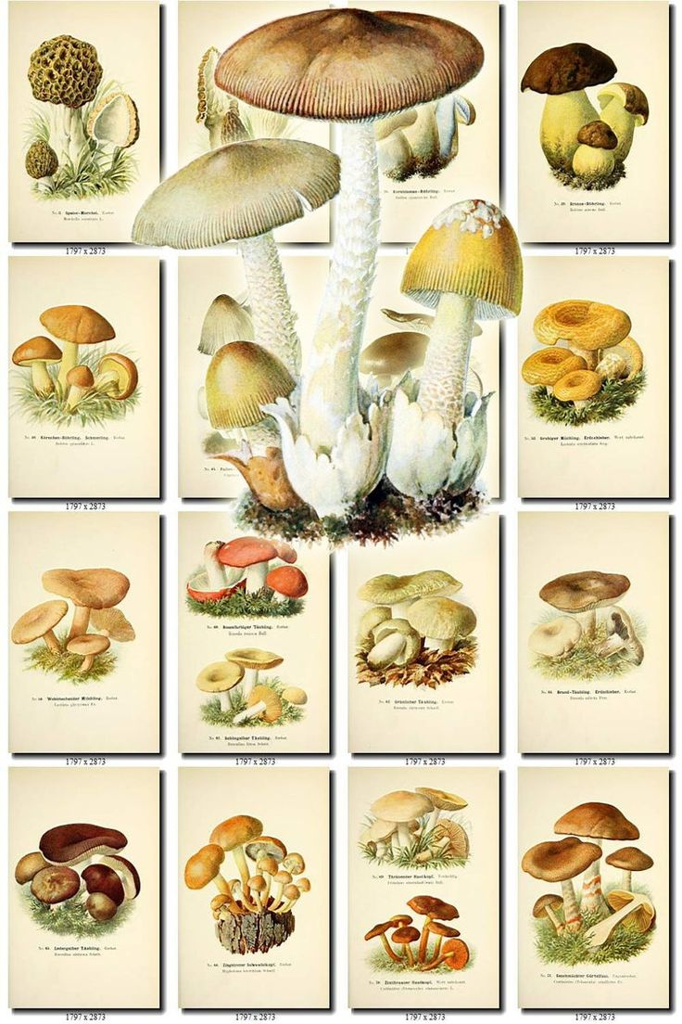

**Importing the Liabraries**:-

import numpy as np

import pandas as pd

import seaborn as sns

import matplotlib.pyplot as plt

from sklearn.model_selection import train_test_split

from sklearn.preprocessing import LabelEncoder

from sklearn.tree import DecisionTreeClassifier,export_graphviz

from sklearn.metrics import classification_report,confusion_matrix,precision_recall_curve,auc,roc_curve

**Getting the data :-**

df=pd.read_csv('mushroom project.csv')

df

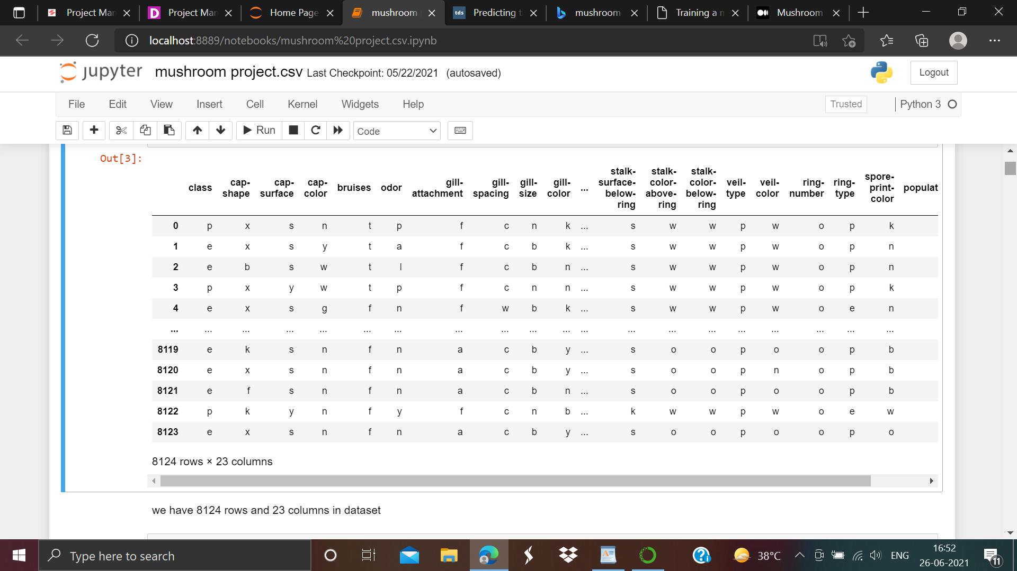

We have 8124 rows and 23 columns in our dataset.

2. **Data Analysis:-**

**df.info()**

As screen shot attached below:-

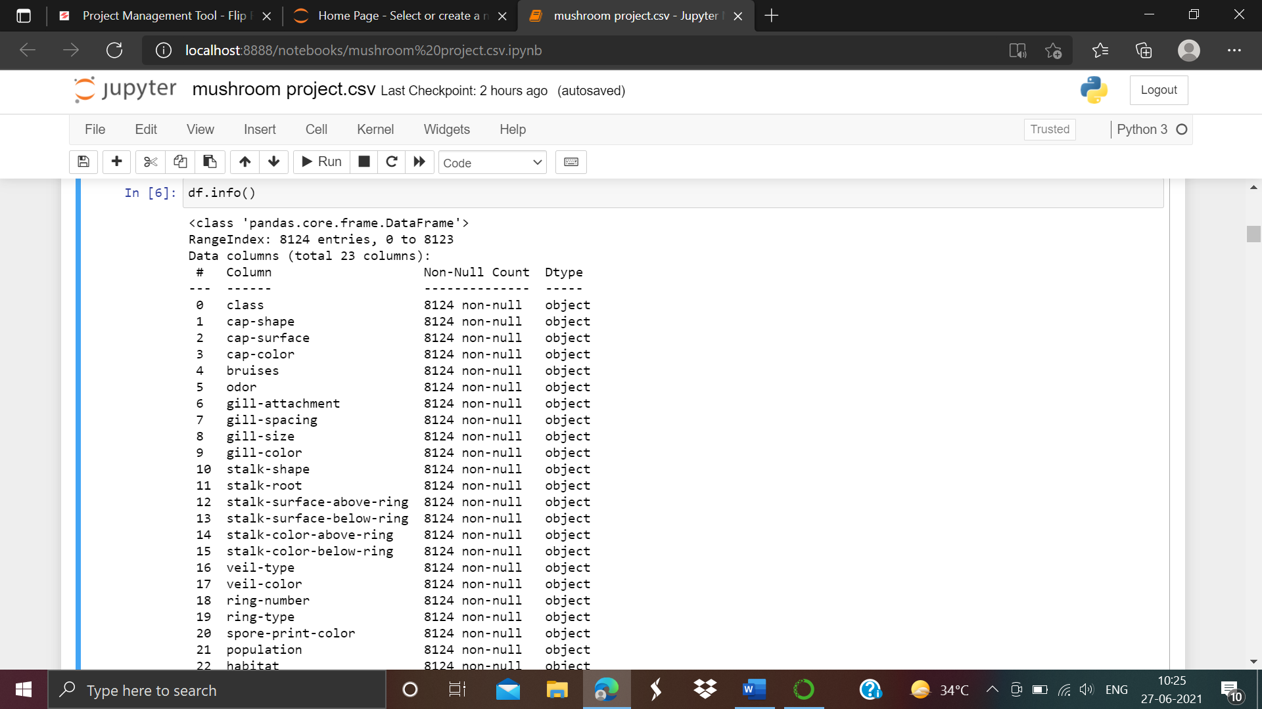

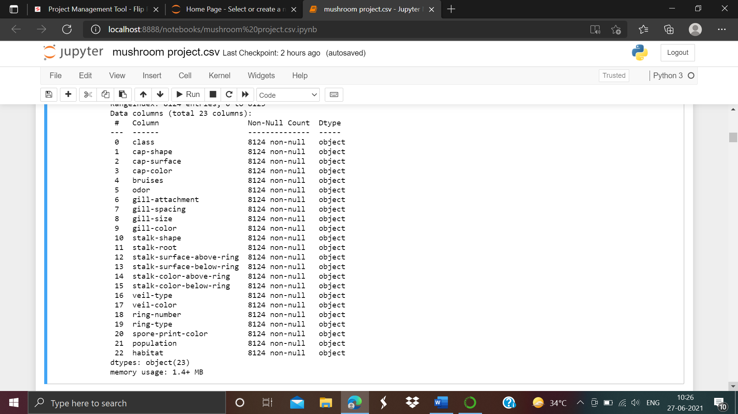

this will give us small knowledge about our dataset including non null values, memory usage and dtype values etc.

This dataset consists of 8124 training examples, each representing a single mushroom. The first column is the target variable containing the class labels, identifying whether the mushroom is poisonous or edible. The remaining columns are 22 discrete features that describe the mushroom in some observable way; their values are encoded by characters.

**df.describe()**

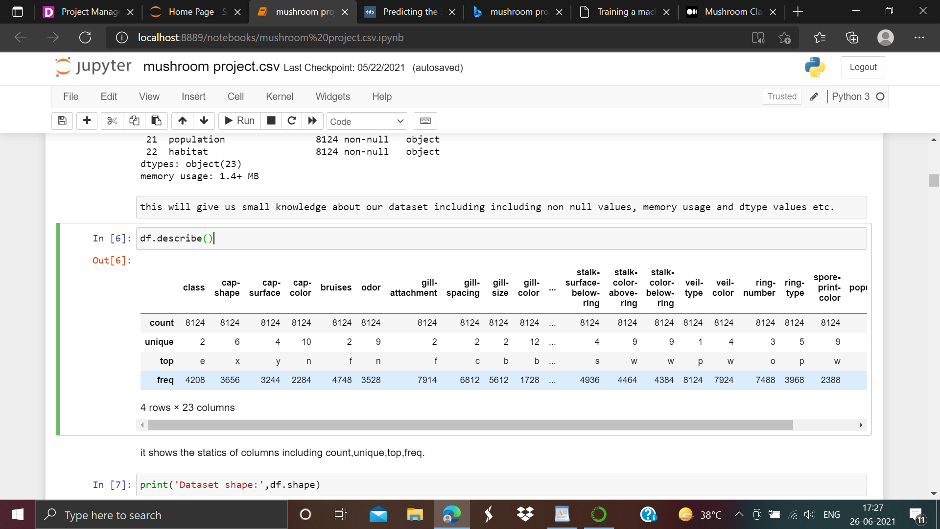

Above we can see the statistics and description of our dataset. It consist of terms like top, frequency,uniqueness and count value.

**df.head()**

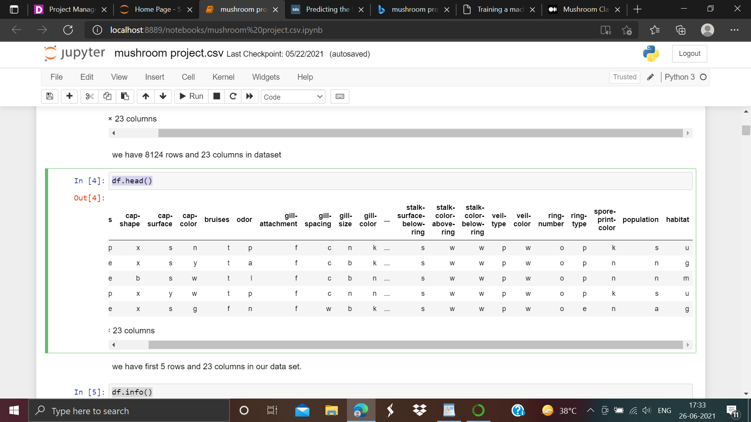

Above we can see first 5 rows and 23 columns in our dataset.

**df.columns**

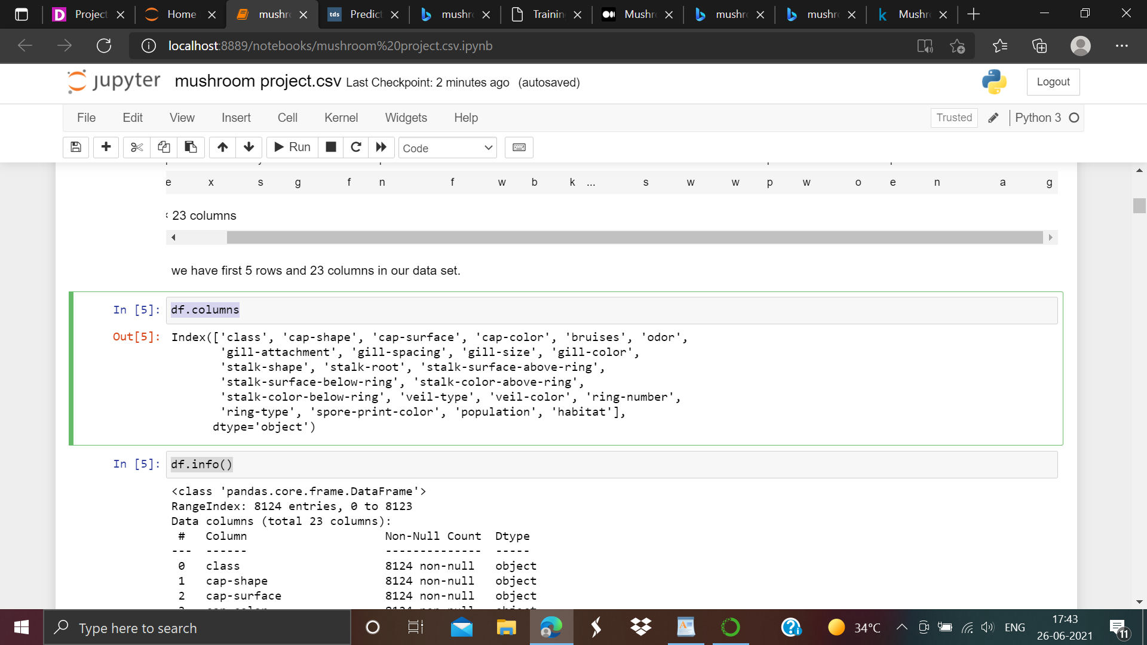

As we can see from the above there are number of columns present in our Dataset. Columns names are given below:-

'class', 'cap-shape', 'cap-surface', 'cap-color', 'bruises', 'odor',

'gill-attachment', 'gill-spacing', 'gill-size', 'gill-color',

'stalk-shape', 'stalk-root', 'stalk-surface-above-ring',

'stalk-surface-below-ring', 'stalk-color-above-ring',

'stalk-color-below-ring', 'veil-type', 'veil-color', 'ring-number',

'ring-type', 'spore-print-color', 'population', 'habitat'

Now i am going to calculate the unique values of target variable "Class" as we can see below:-

**df['class'].unique()**

**df['class'].value_counts()**

The follwing outputs will come:-

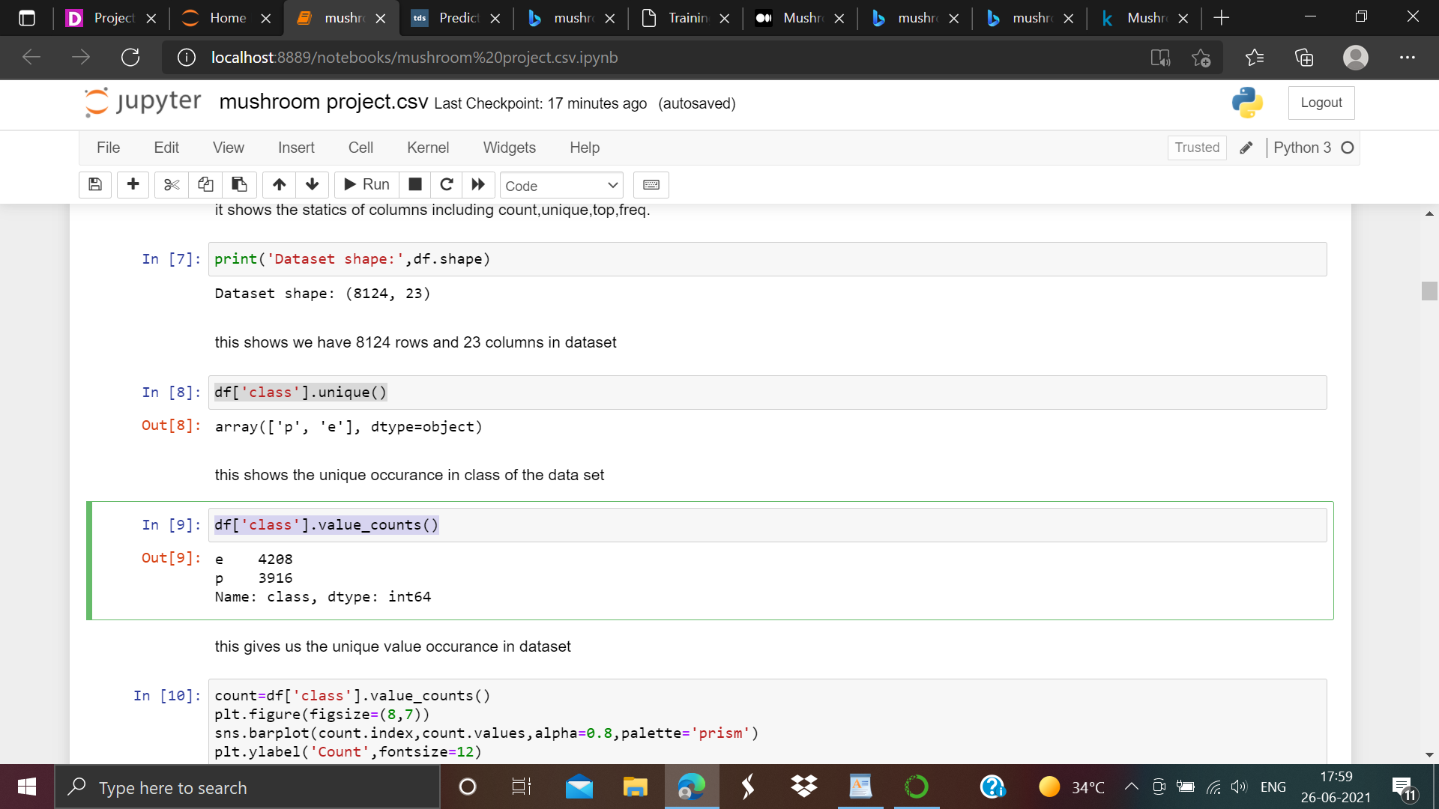

In this we can see the unique occurance of ['p','e'] in class of the data set having values separately. 'e' consist of 4208 values and 'p' consist of 3916 values.

**df=df.astype('category')**

**df.dtypes**

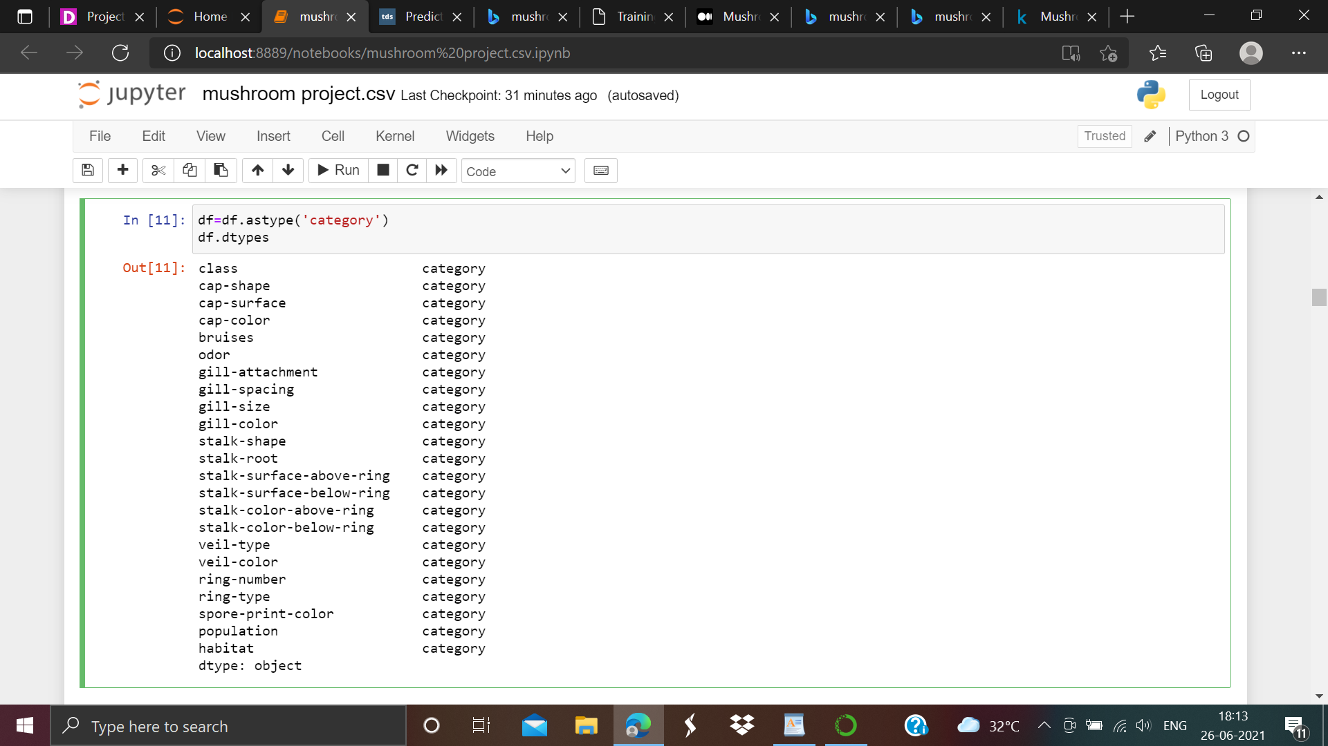

**From the above we have converted columns in 'category'.As we can see all the 23 columns features are in categorical form.**

**3. EDA Concluding Remark**

**Data Visualization:-**

count=df['class'].value_counts()

plt.figure(figsize=(8,7))

sns.barplot(count.index,count.values,alpha=0.8,palette='prism')

plt.ylabel('Count',fontsize=12)

plt.xlabel('Class',fontsize=12)

plt.title('Number of poisonous/edible mushrooms')

plt.show()

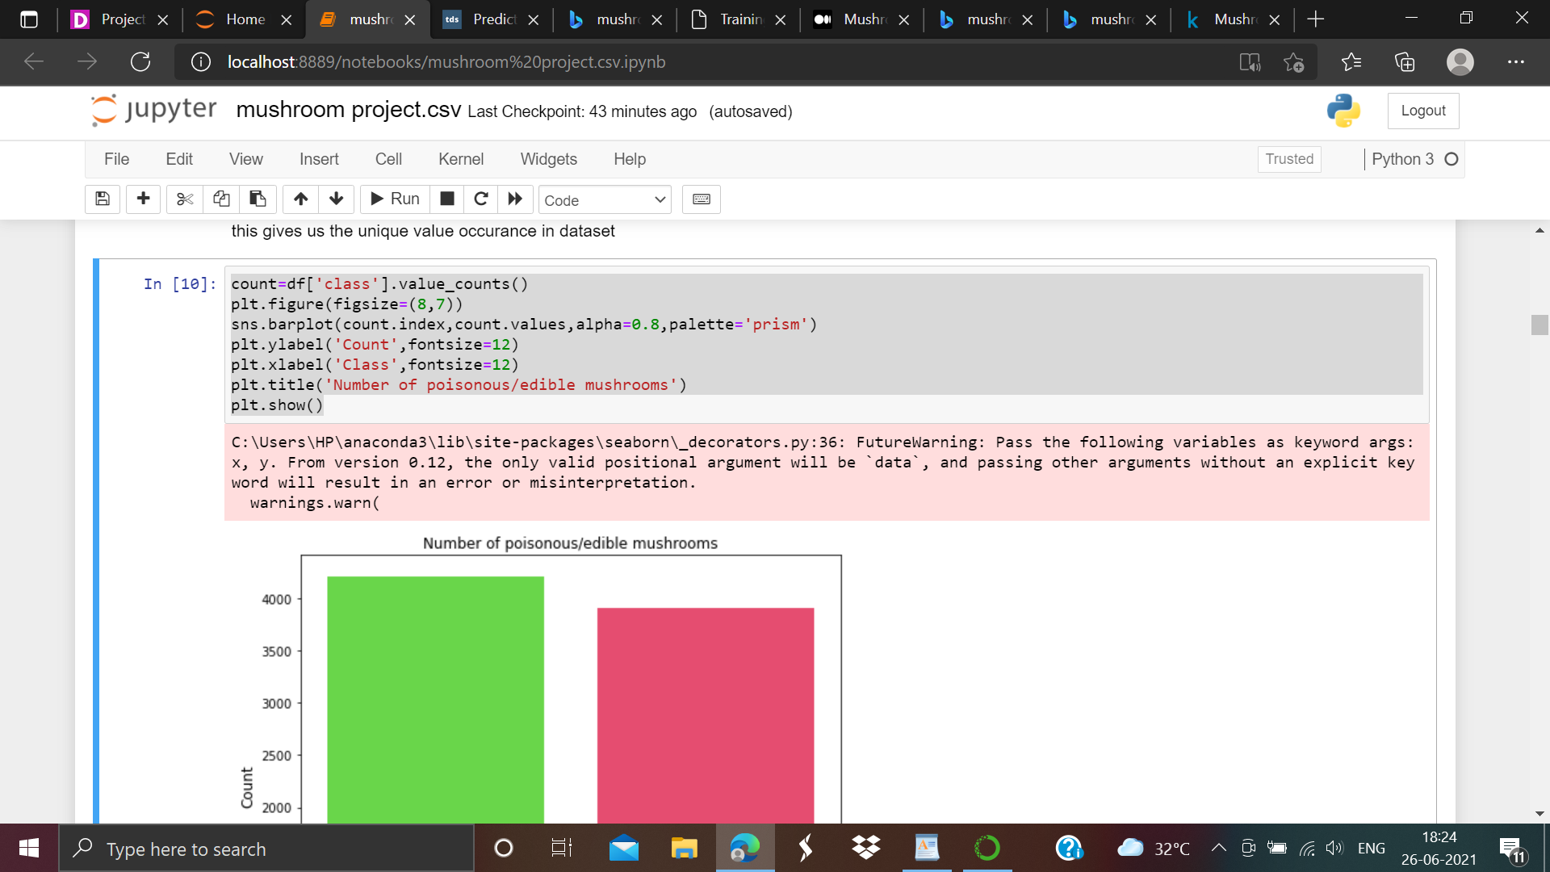

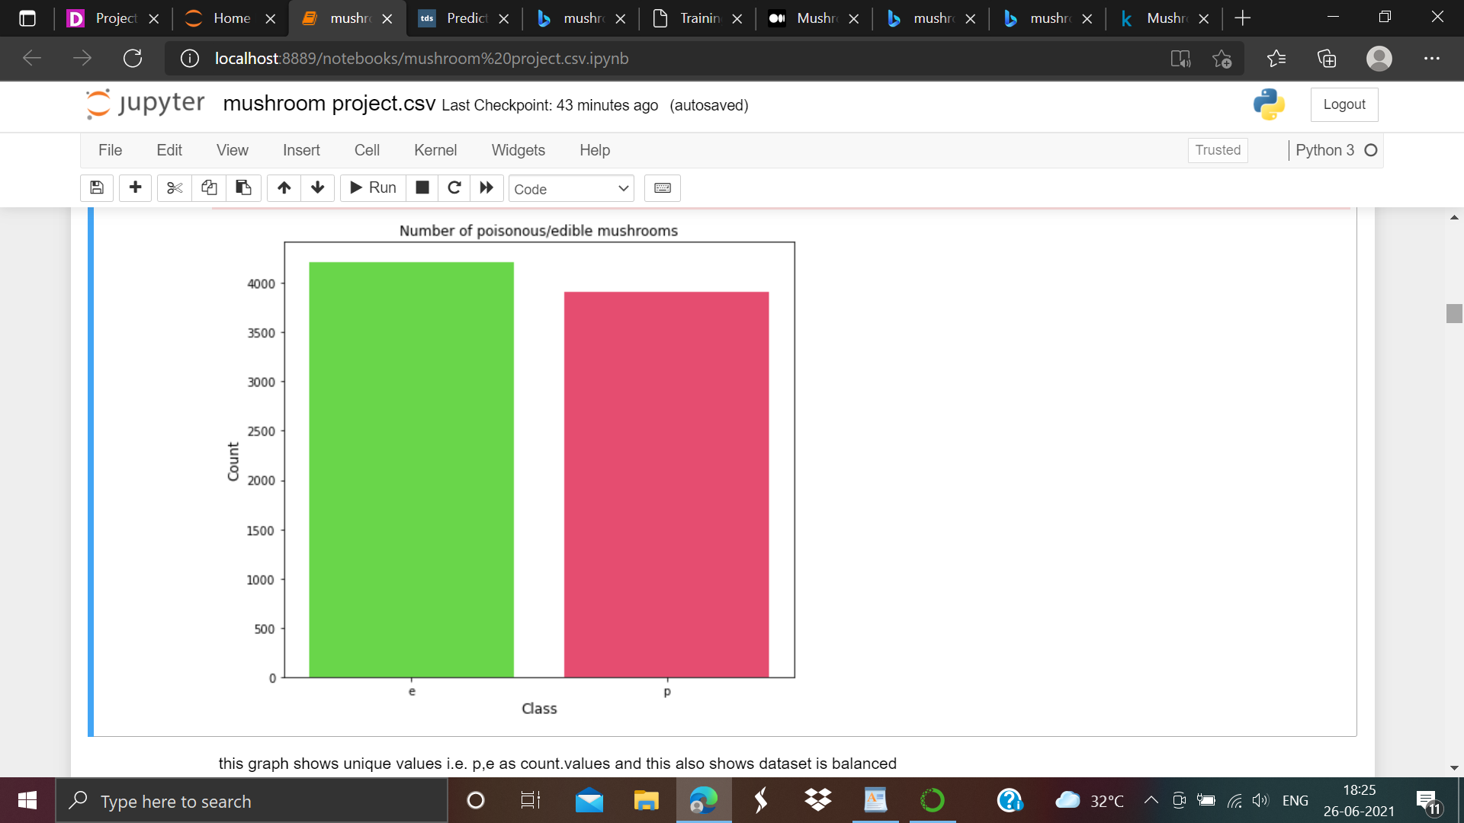

**From the above Graph we can see that e represents the edible mushrooms and p represents the poisonous mushrooms. Number of poisonous mushrooms is almost equal to edible mushroom.So we can say it is balanced .**

**Label Encoding:-**

The data is categorical so we’ll use **LabelEncoder** to convert it to ordinal. **LabelEncoder** converts each value in a column to a number.

This approach requires the category column to be of ‘**category**’ datatype. By default, a non-numerical column is of ‘**object**’ datatype. From the **df.describe()**method, we saw that our columns are of ‘object’ datatype. So we will have to change the type to ‘category’ before using this approach.

**labelencoder=LabelEncoder()**

**for column in df.columns:**

**df[column]=labelencoder.fit_transform(df[column])**

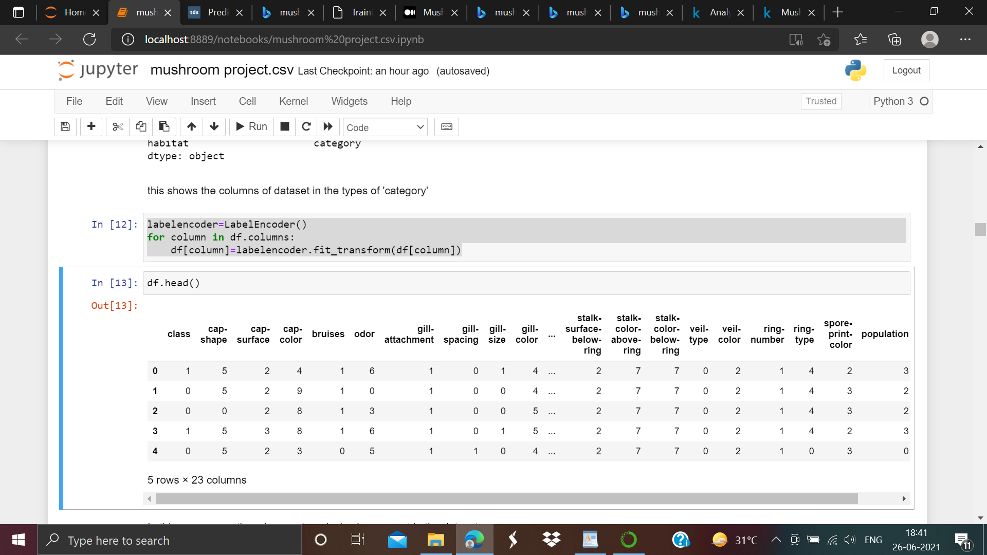

In this we can see there is no categorical value present in the dataset.

we can see column veil type is zero and no contribute to the dataset. so we have to remove it.

**df['veil-type']**

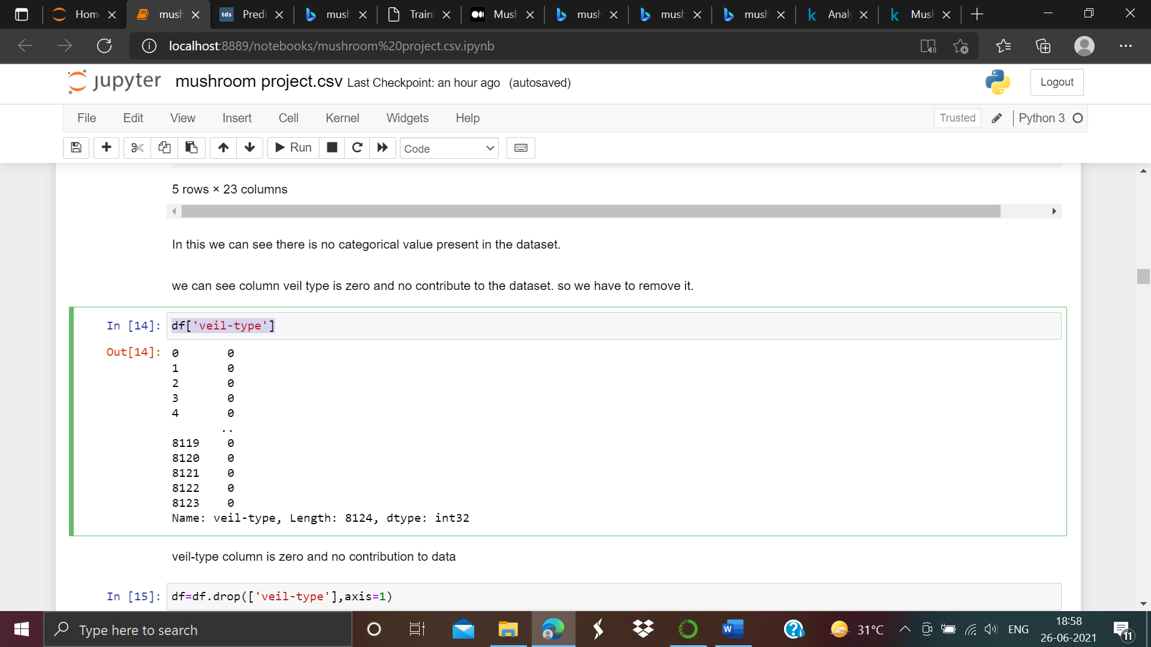

As we can see the veil type is zero so there is no contribution to dataset.

df=df.drop(['veil-type'],axis=1)

df_div=pd.melt(df,'class',var_name='Characteristics')

fig,ax=plt.subplots(figsize=(16,6))

p=sns.violinplot(ax=ax,x='Characteristics',y='value',hue='class',split=True, data=df_div,inner='quartile', palette='Set1')

df_no_class=df.drop(['class'],axis=1)

p.set_xticklabels(rotation=90,labels=list(df_no_class.columns));

Output of the violin plot:-

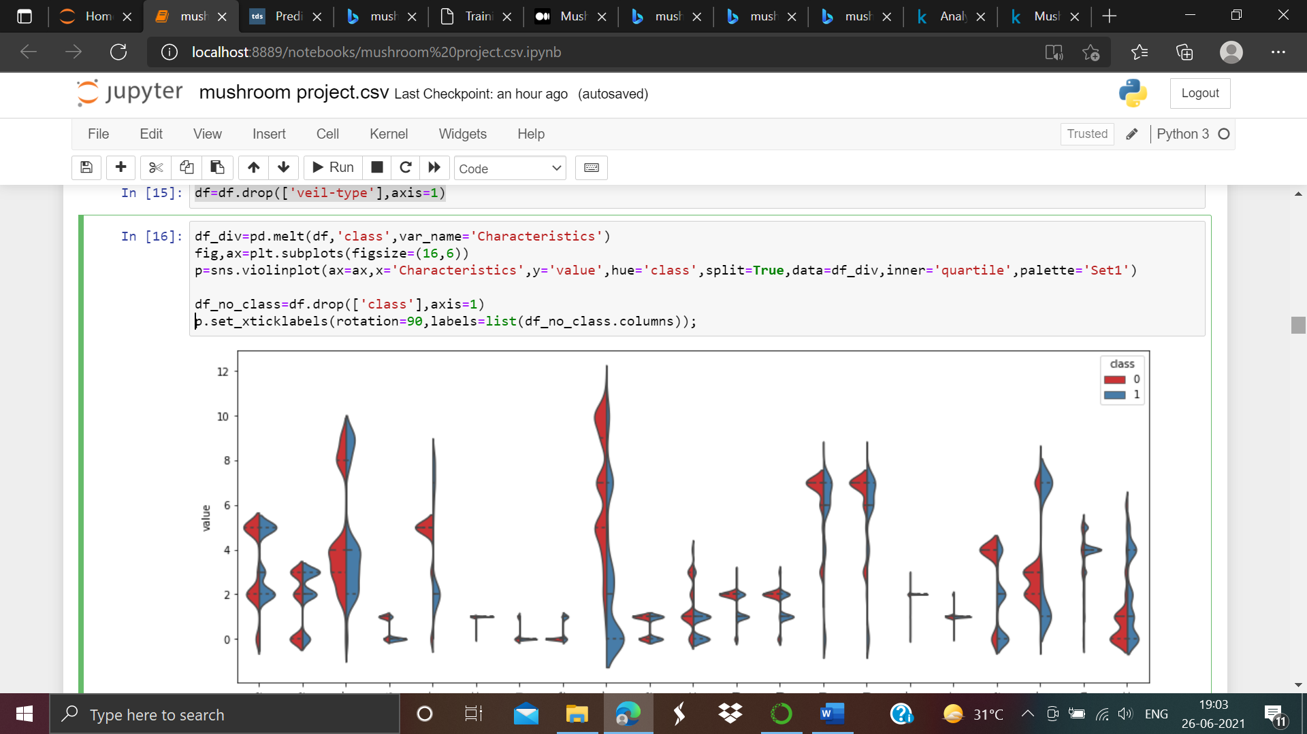

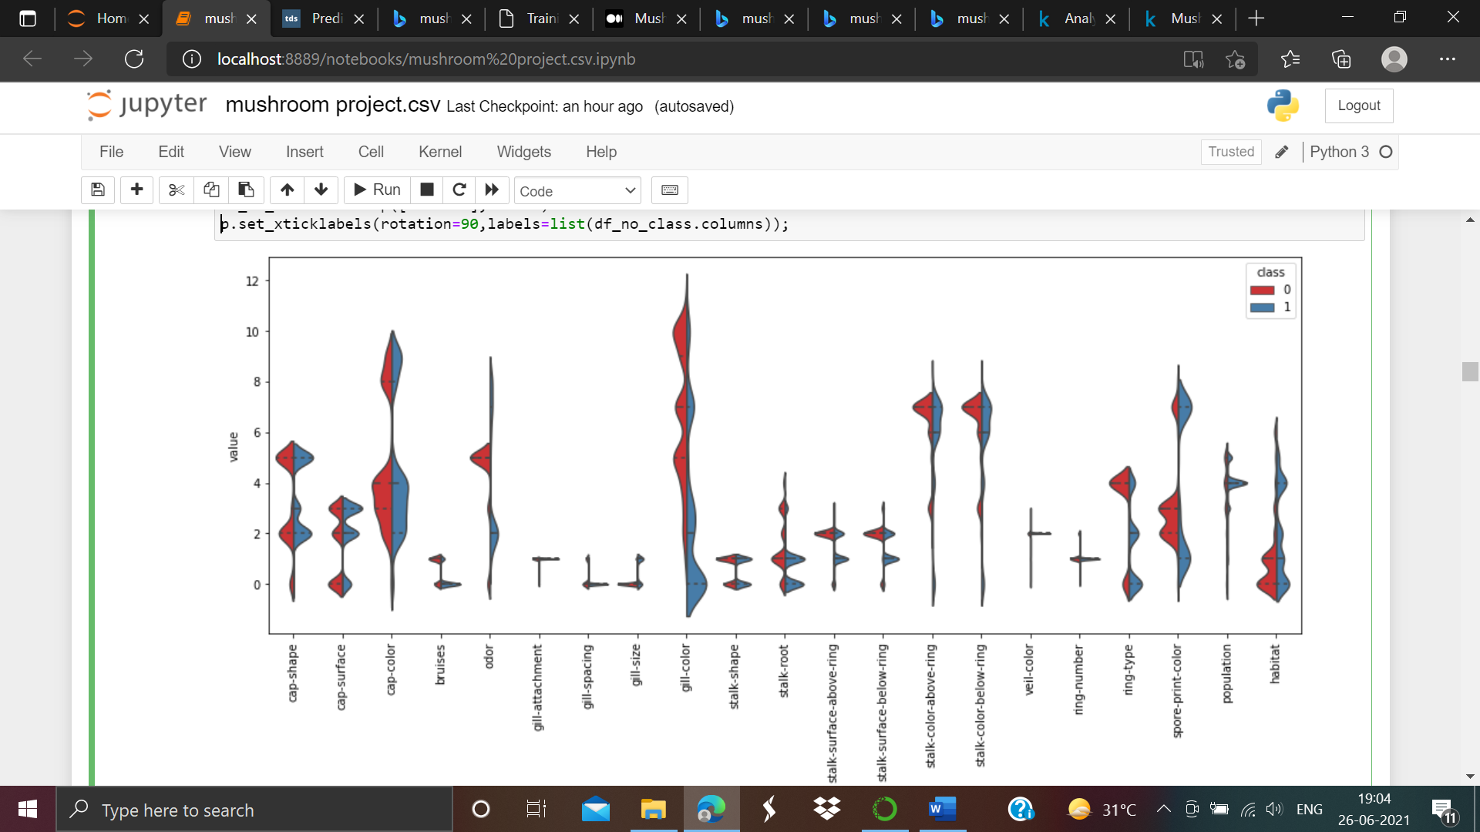

The violin plot below represents the distribution of the classification characteristics. It is possible to see that the **“gill-color”** property of the mushroom breaks into two parts, one below 3 and one above 3, that may contribute to the classification.

Correlation between the variables:-

plt.figure(figsize=(14,12))

sns.heatmap(df.corr(),linewidths=.1,cmap='Oranges',annot=True,annot_kws={'size':7})

plt.yticks(rotation=0);

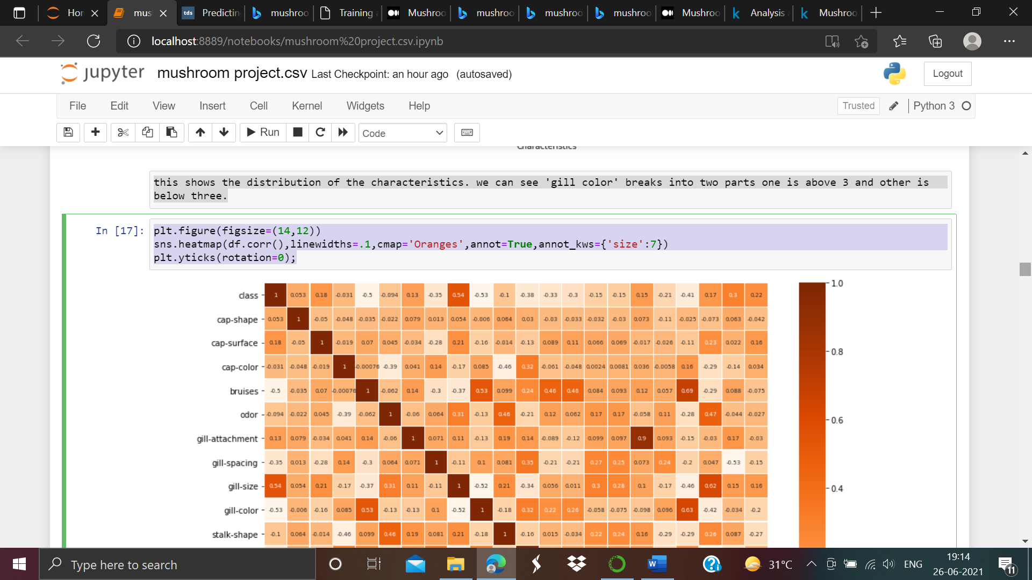

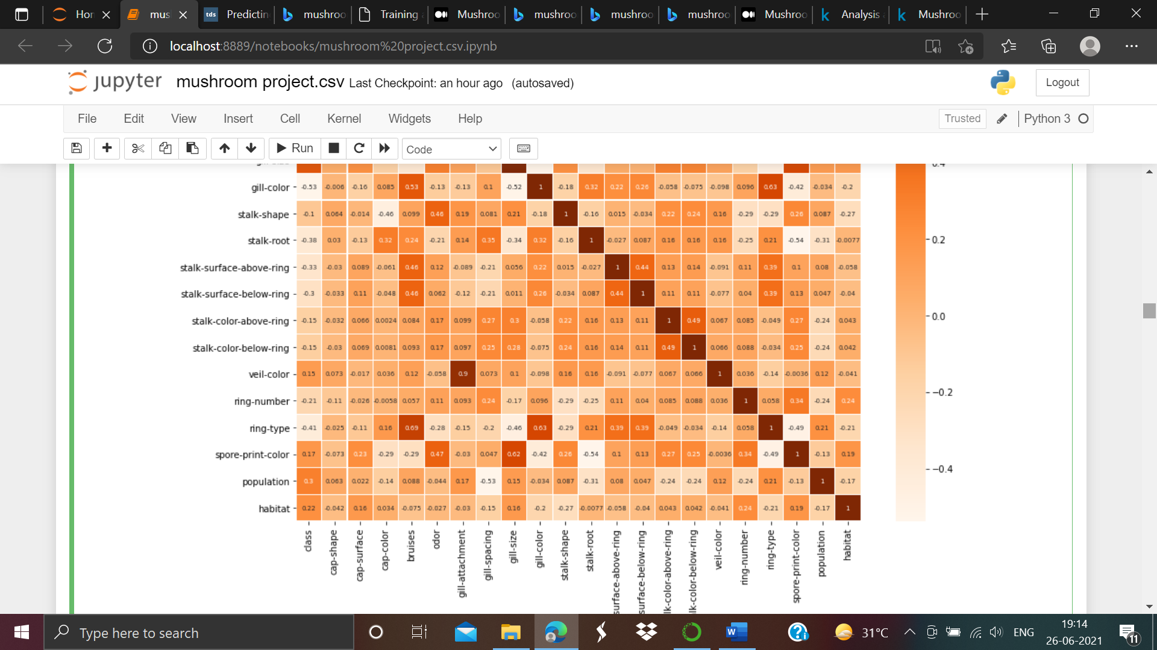

Above we can see the output of heatmap.

As we can observed that the least correlating variable is ‘gill color’. In this case, **“gill-color”** is**-0.53** so we have to consider on this.

df[['class','gill-color']].groupby(['gill-color'],

as_index=False).mean().sort_values(by='class',ascending=False)

as screen shot attached below:-

The following output will come:-

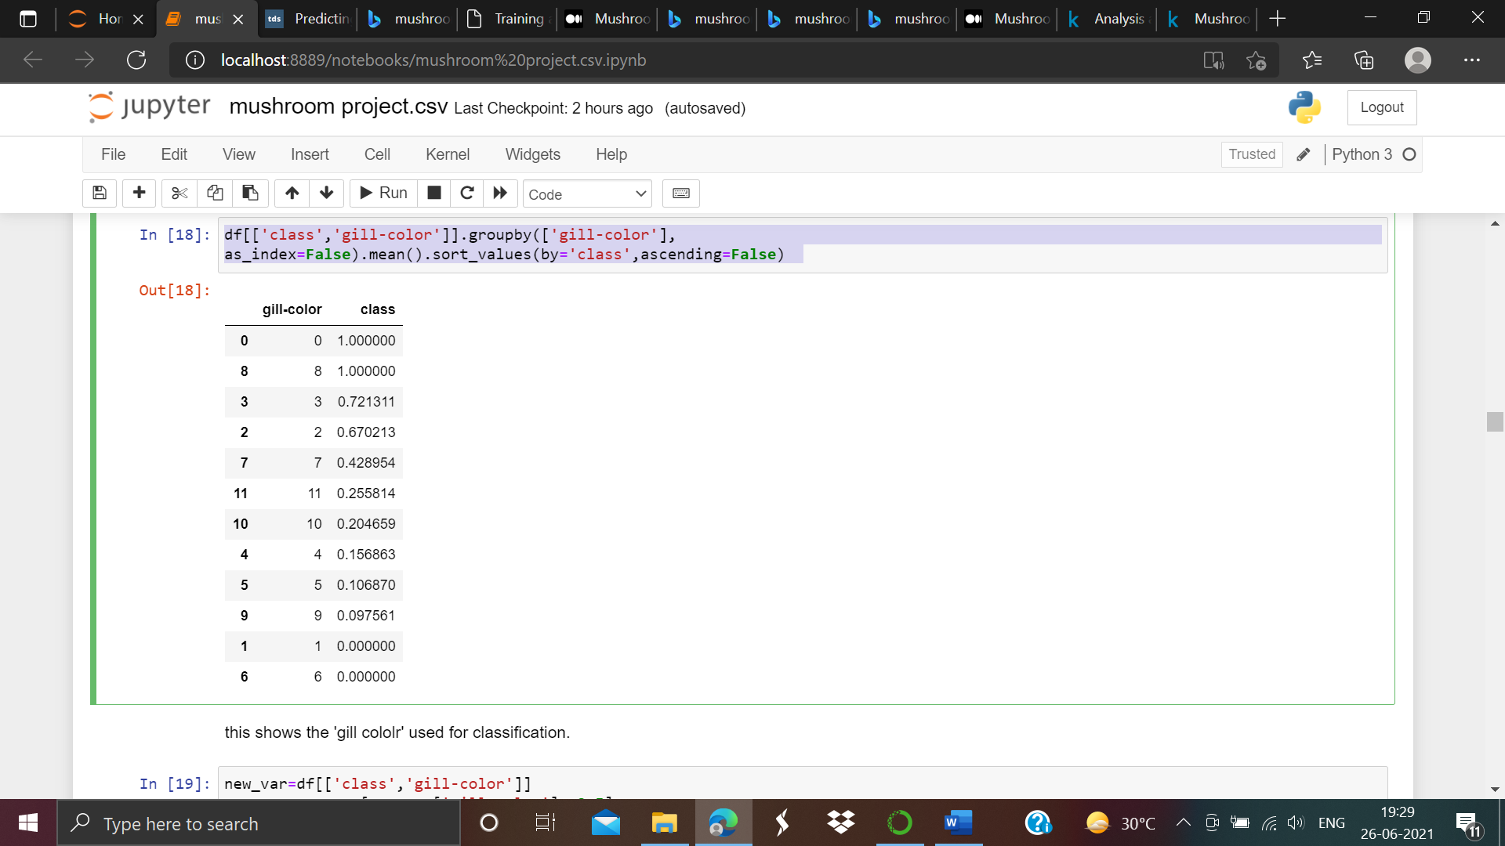

new_var=df[['class','gill-color']]

new_var=new_var[new_var['gill-color']<=3.5]

sns.factorplot('class',col='gill-color',data=new_var,kind='count',size=4.5,aspect=.8,col_wrap=4);

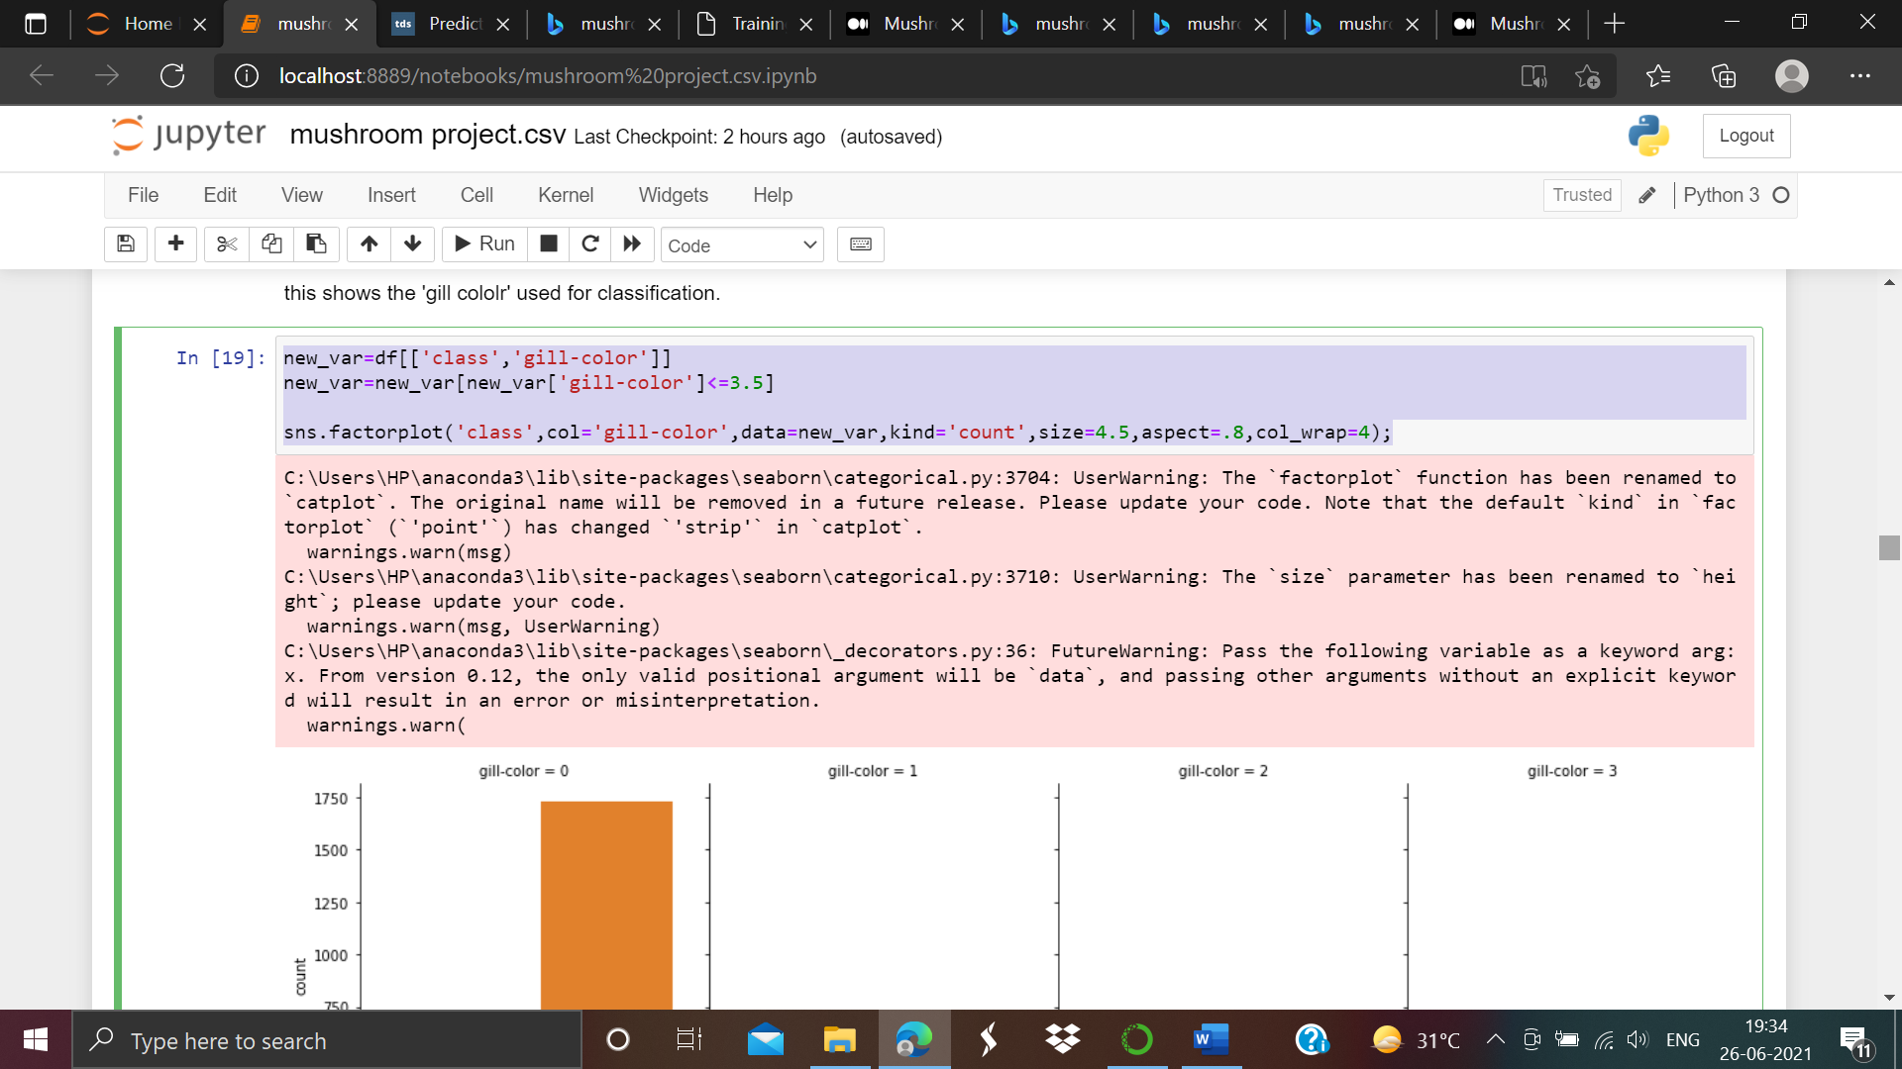

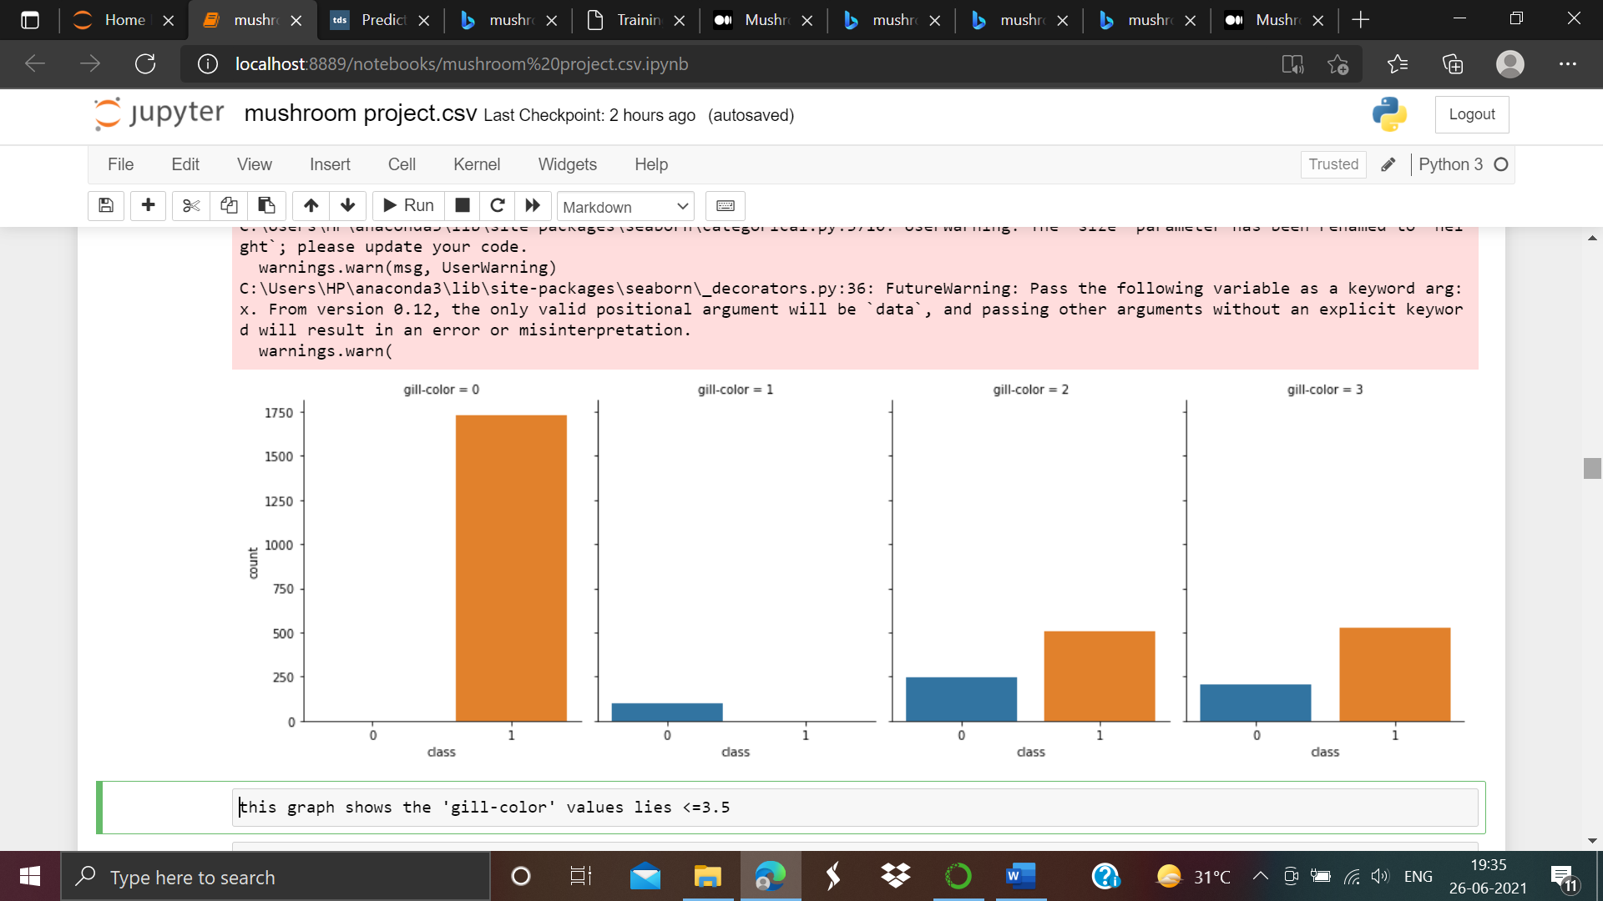

this graph shows the 'gill-color' values lies <=3.5

new_var=df[['class','gill-color']]

new_var=new_var[new_var['gill-color']>3.5]

sns.factorplot('class',col='gill-color',data=new_var,kind='count',size=4.5,aspect=.8,col_wrap=4);

as screen shot attached below:-

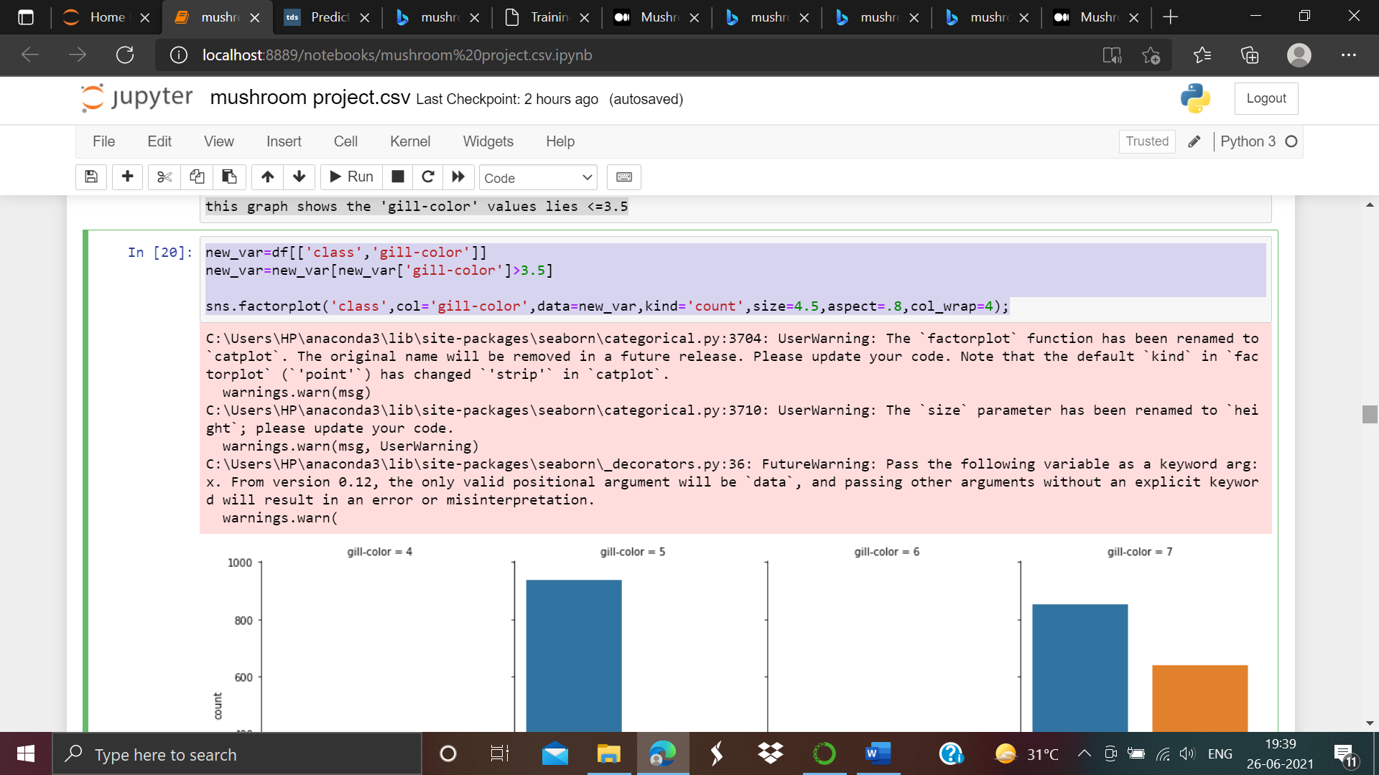

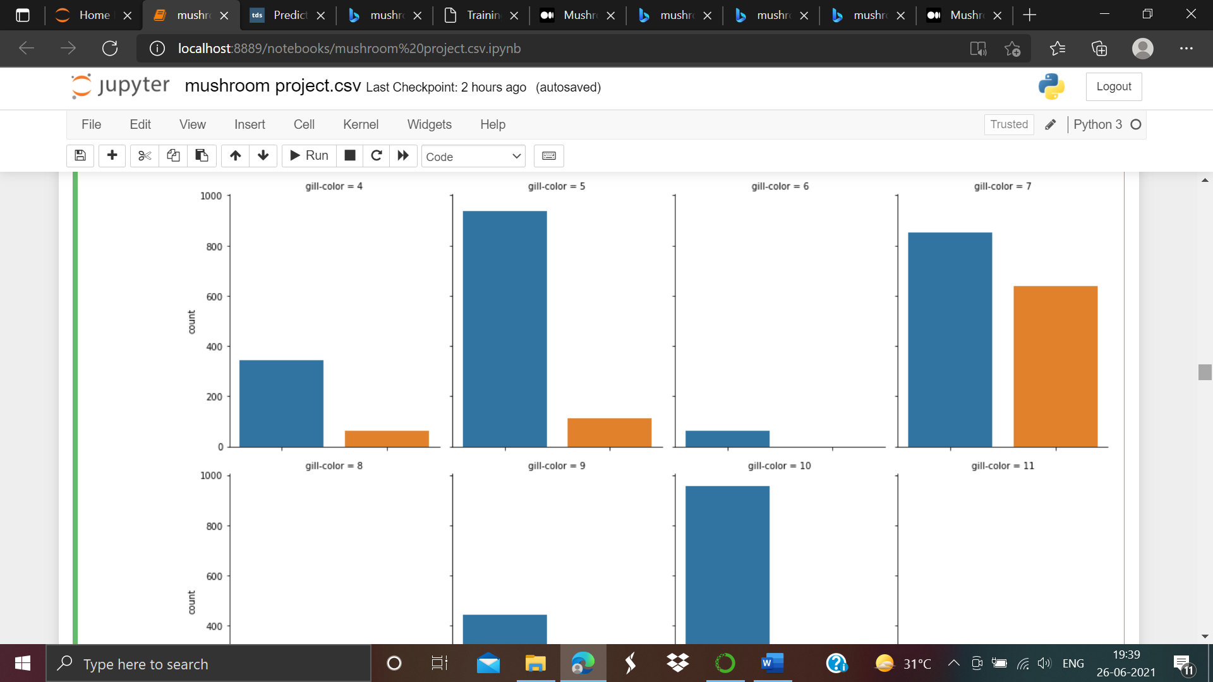

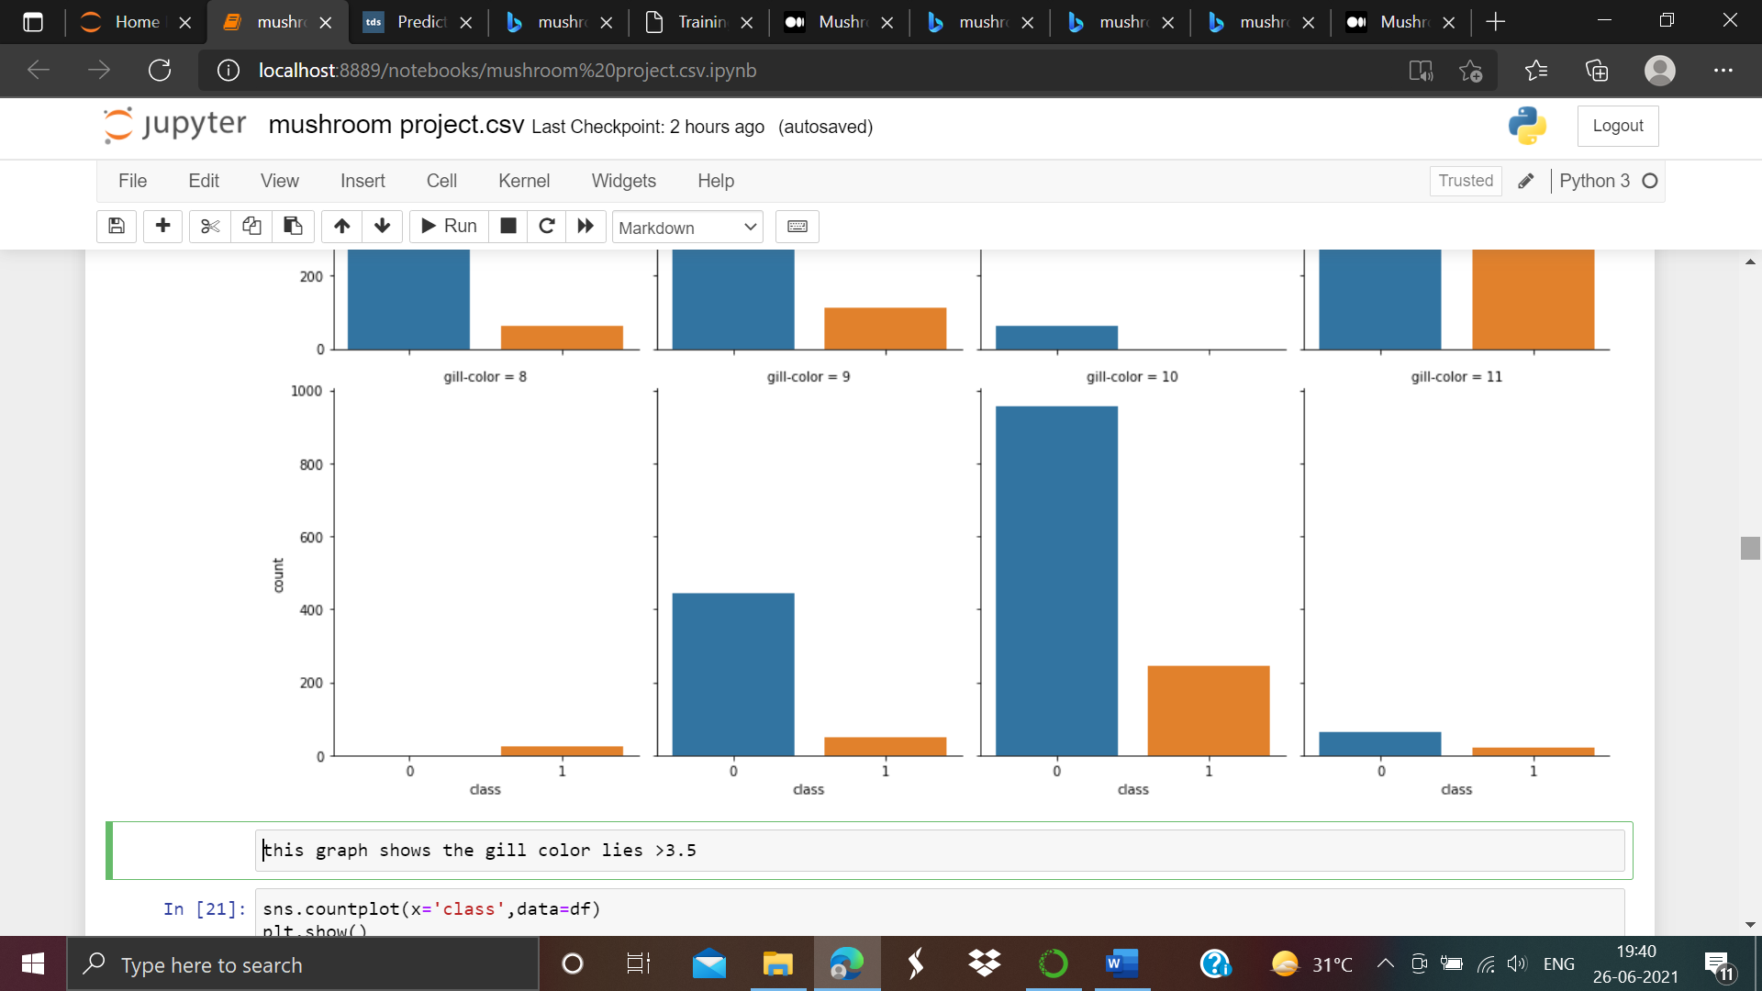

this graph shows the gill color lies >3.5

sns.countplot(x='class',data=df)

plt.show()

as screen shot given below:-

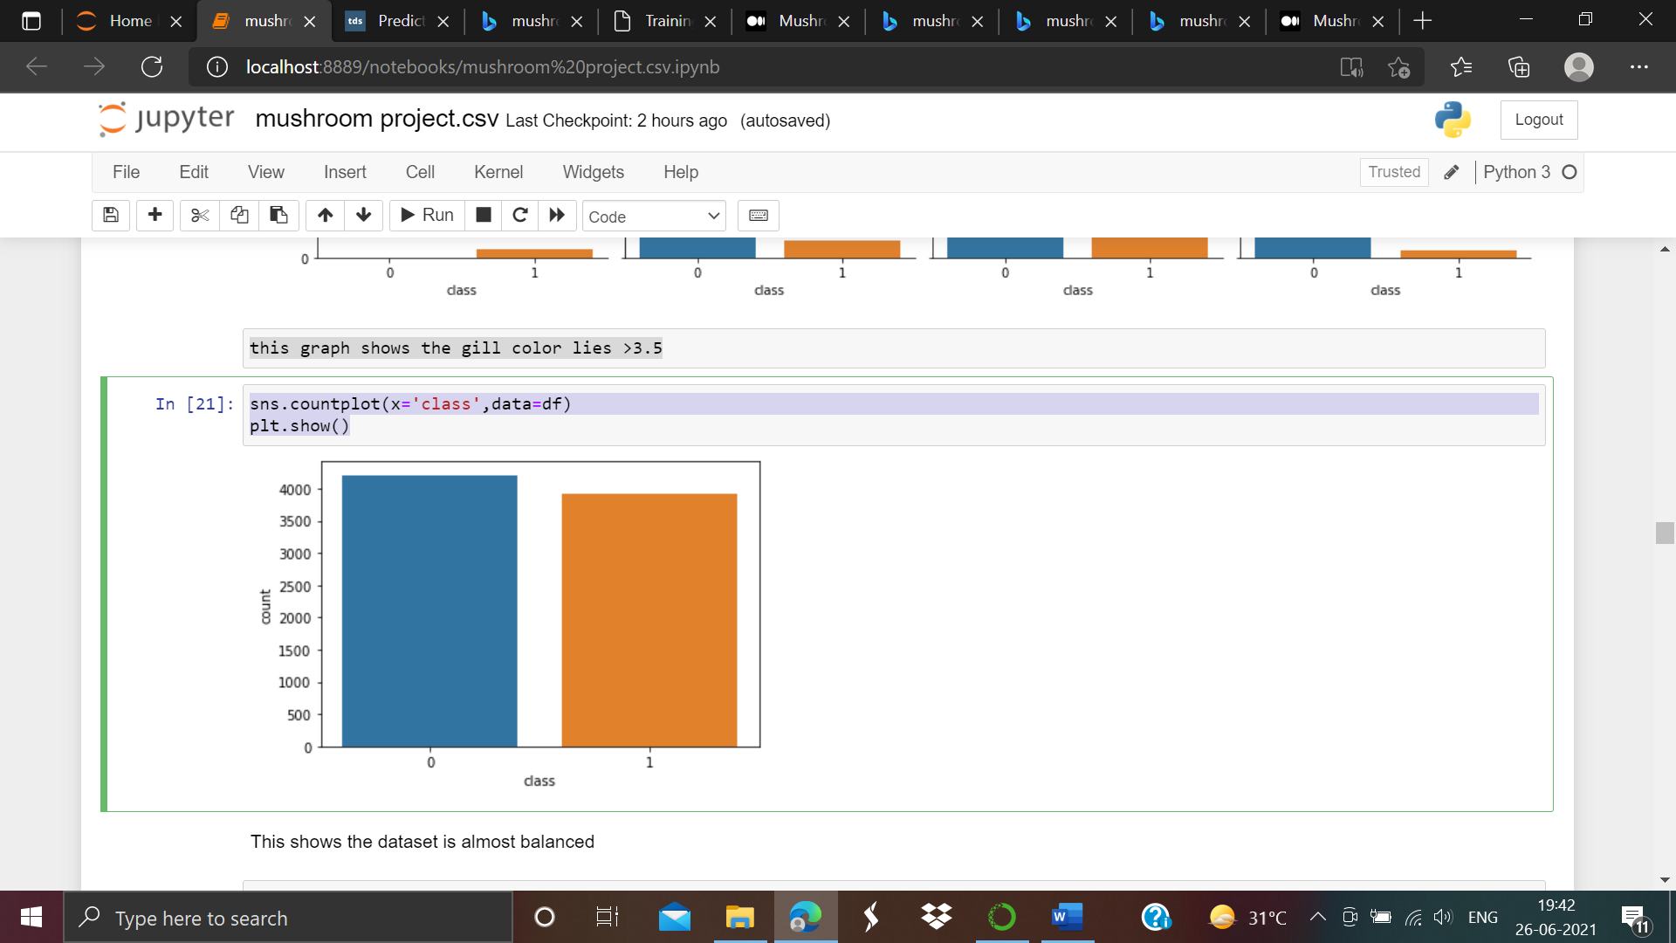

From the above observations we observed that dataset is almost balanced.

Z score Calculation:-

Now we have to find out the z score value. So let’s apply algorithms to calculate the z score value:-

First of all we have to import z score library as shown below:-

from scipy.stats import zscore

zscr=np.abs(zscore(df))

threshold=3

print(np.where(zscr>3))

as screen shot attached below:-

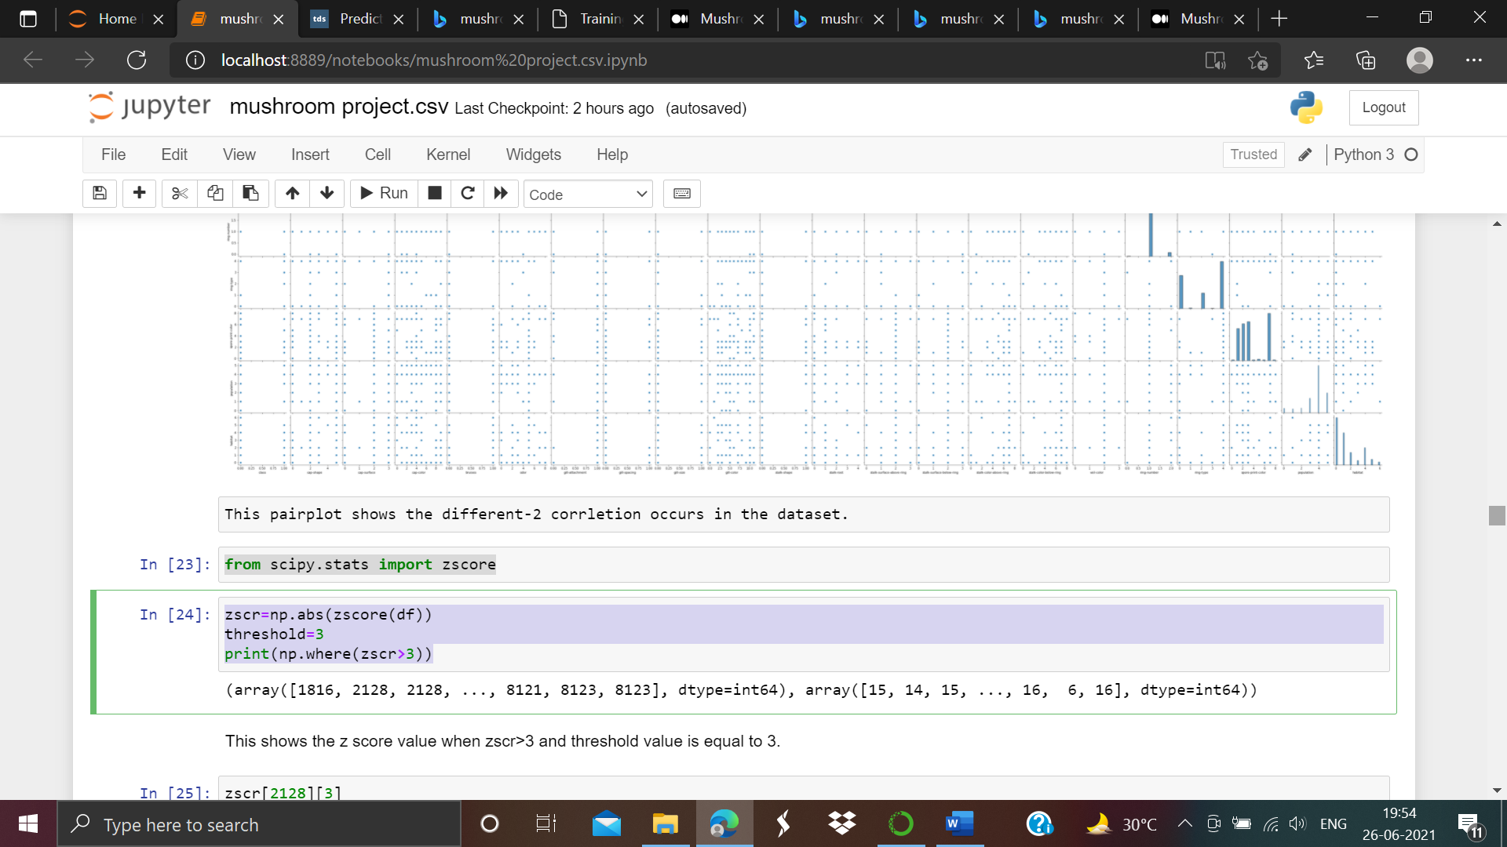

As we observed that from the above the z score value when zscr>3 and threshold value is equal to 3.

For Example :-

zscr[2128][3]

the value is 0.5910746076888268

this shows the z score value of 2128 row from the dataset when threshold value is 3.

Checking the skewness of the dataset:-

dfnew=df[(zscr<3).all(axis=1)]

df=dfnew

df_x=df.drop(columns=['class'])

y=df[['class']]

for i in df_x.columns:

if df_x[i].skew()>0.5:

df_x[i]=np.cbrt(df_x[i])

if df_x[i].skew()<0.5:

df_x[i]=np.cbrt(df_x[i])

df_x.skew()

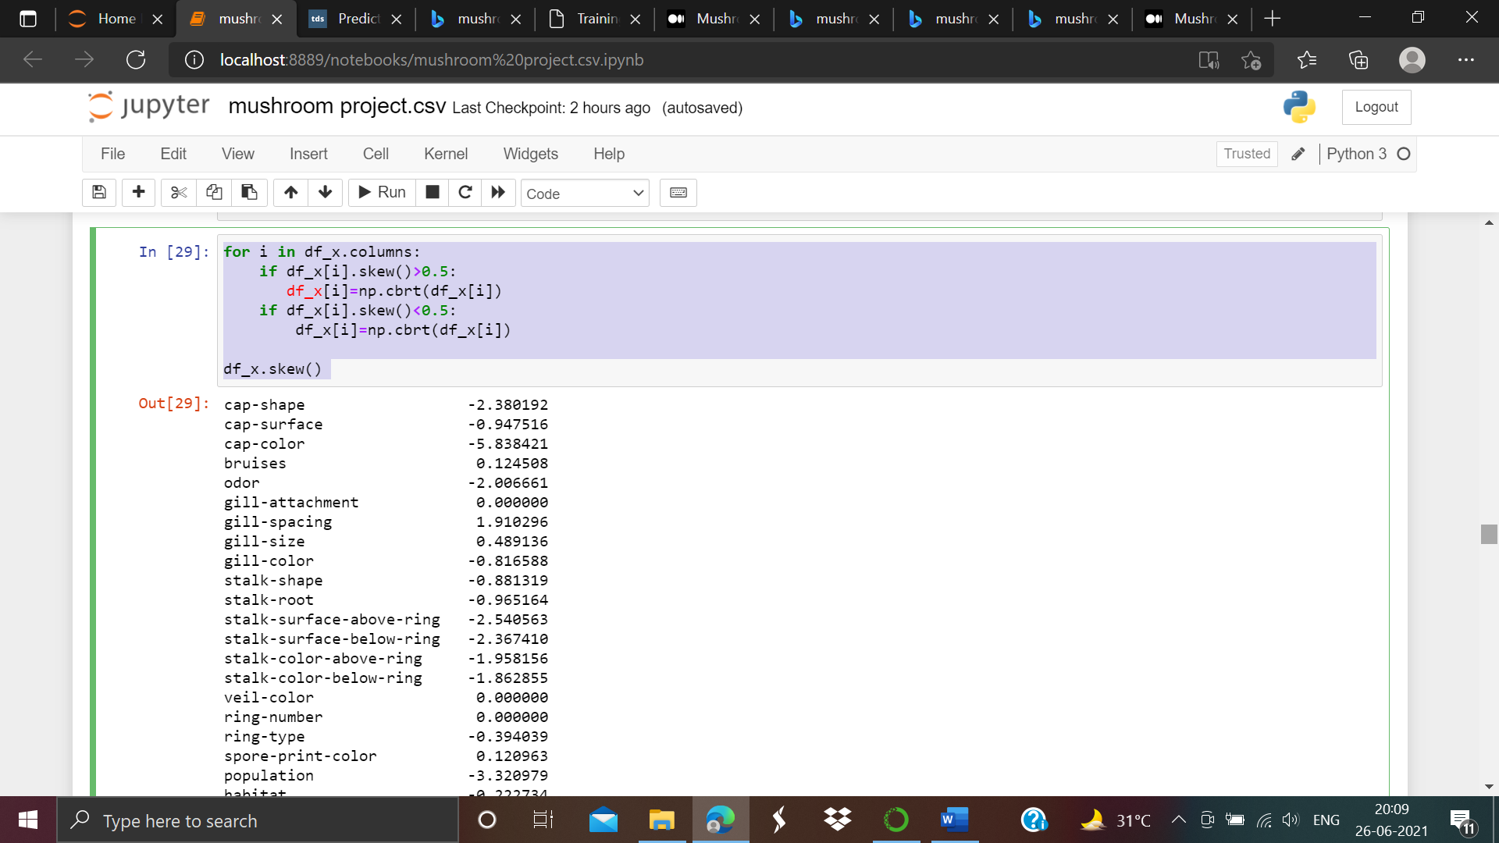

This shows the skewness of the dataset having range lies between

<,>0.5

4. Preprocessing the Data:-

We have to preprocessed the data by setting x,y and splitting the data into train and test respectively.

Since we want to predict the class of the mushroom, we will drop the **‘class’** column.

First we have to import scalling the dataset and we have import first standard scaler as shown below:-

Here the below mentioned output will come:-

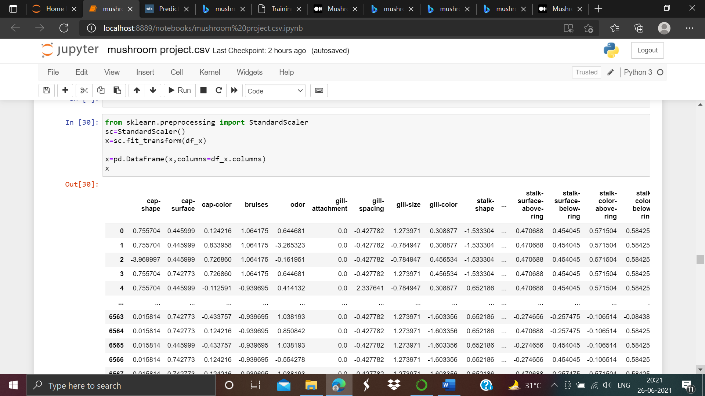

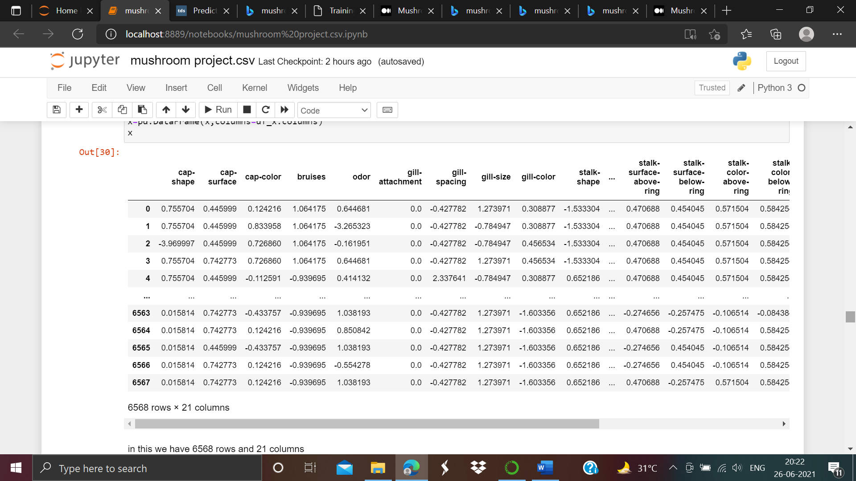

After apply this we have 6568 rows and 21 columns in our dataset.

Some machine learning algorithms, such as Standard Scaler, only work if the features are standardized having zero mean and unit variance; others will converge faster. Only tree-based models see no real benefit from feature standardization, but in general, it doesn't hurt to standardize.

Spiliting the dataset:-

Now we are spiliting our dataset dropping the class column from the dataset. We have to import train test split from sklearn which is shown below:-

from sklearn.model_selection import train_test_split

y=df['class'].values

x=df.drop(['class'],axis=1).values

x_train,x_test,y_train,y_test=train_test_split(x,y,random_state=42,test_size=0.2)

x_train,x_test,y_train,y_test=train_test_split(x,y,test_size=.22,random_state=43)

print(x_train.shape)

print(x_test.shape)

print(y_train.shape)

print(y_test.shape)

The screen shot of output is shown below:-

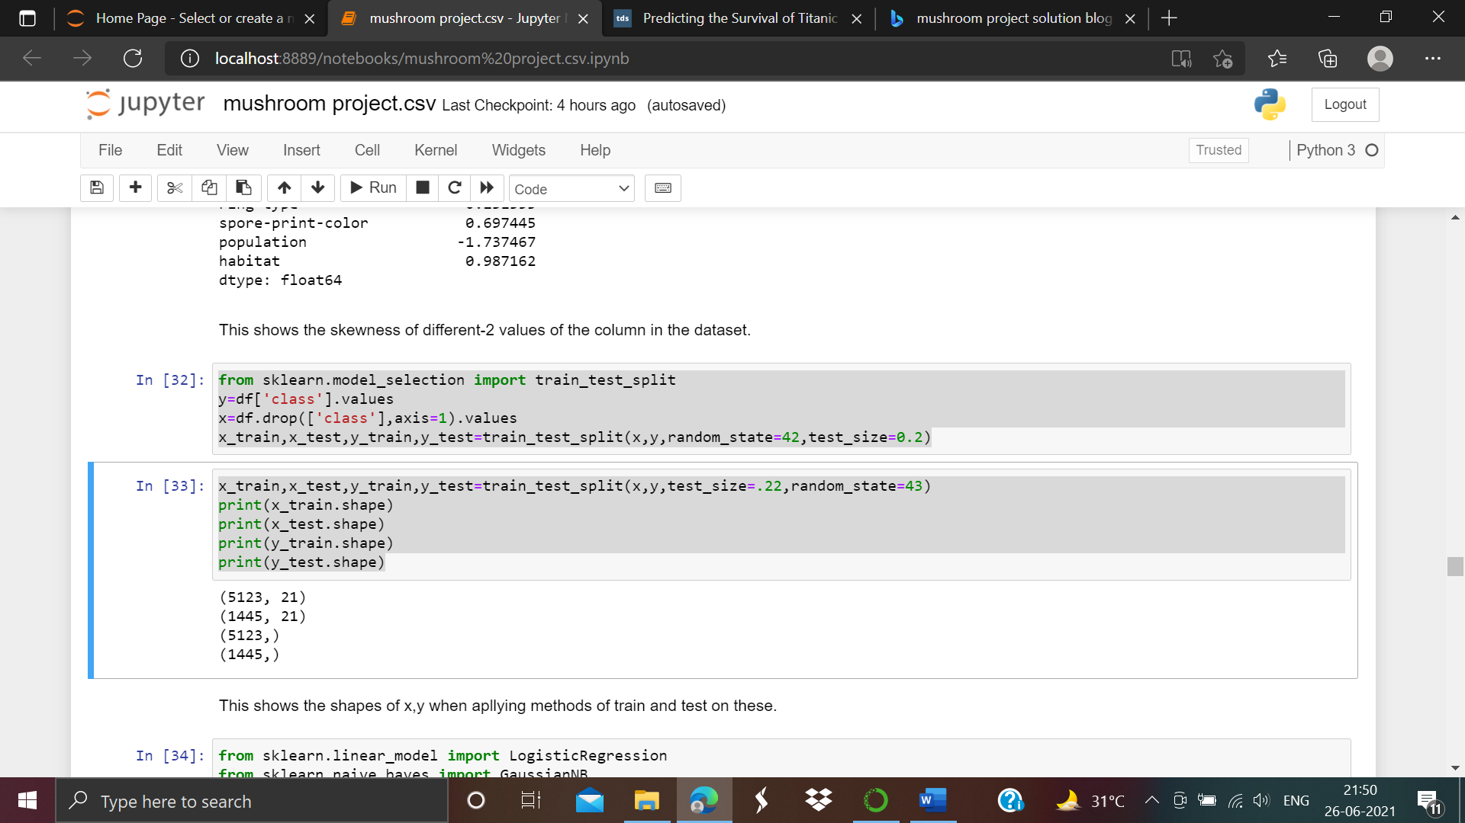

This shows the shapes of x,y respectively when applying methods of train and test on these.

x_train is having 5123 rows and 21 columns.

X_test is having 1445 rows and 21 columns.

y_train is having 5123 rows

y_test is having 1445 rows

5. Building machine learning models:-

For building machine learning models we have to use several Machine learning models and we have to compare their result also. As the given dataset is not providing the information regarding testing the dataset. We have to use the predictions on the training dataset to compare the algorithms with each other.

First of all we have to import the some classification libraries shown below:-

from sklearn.linear_model import LogisticRegression

from sklearn.naive_bayes import GaussianNB

from sklearn.svm import SVC

from sklearn.ensemble import RandomForestClassifier

from sklearn.tree import DecisionTreeClassifier

from sklearn.ensemble import AdaBoostClassifier

from sklearn.metrics import accuracy_score,confusion_matrix,classification_report

These are the classification technique models which we are going to use separately.

LogisticRegression

As we take first classification model LogisticsRegression. In this we can see can we use LogisticsRegression model algorithms screen shot attached below:-

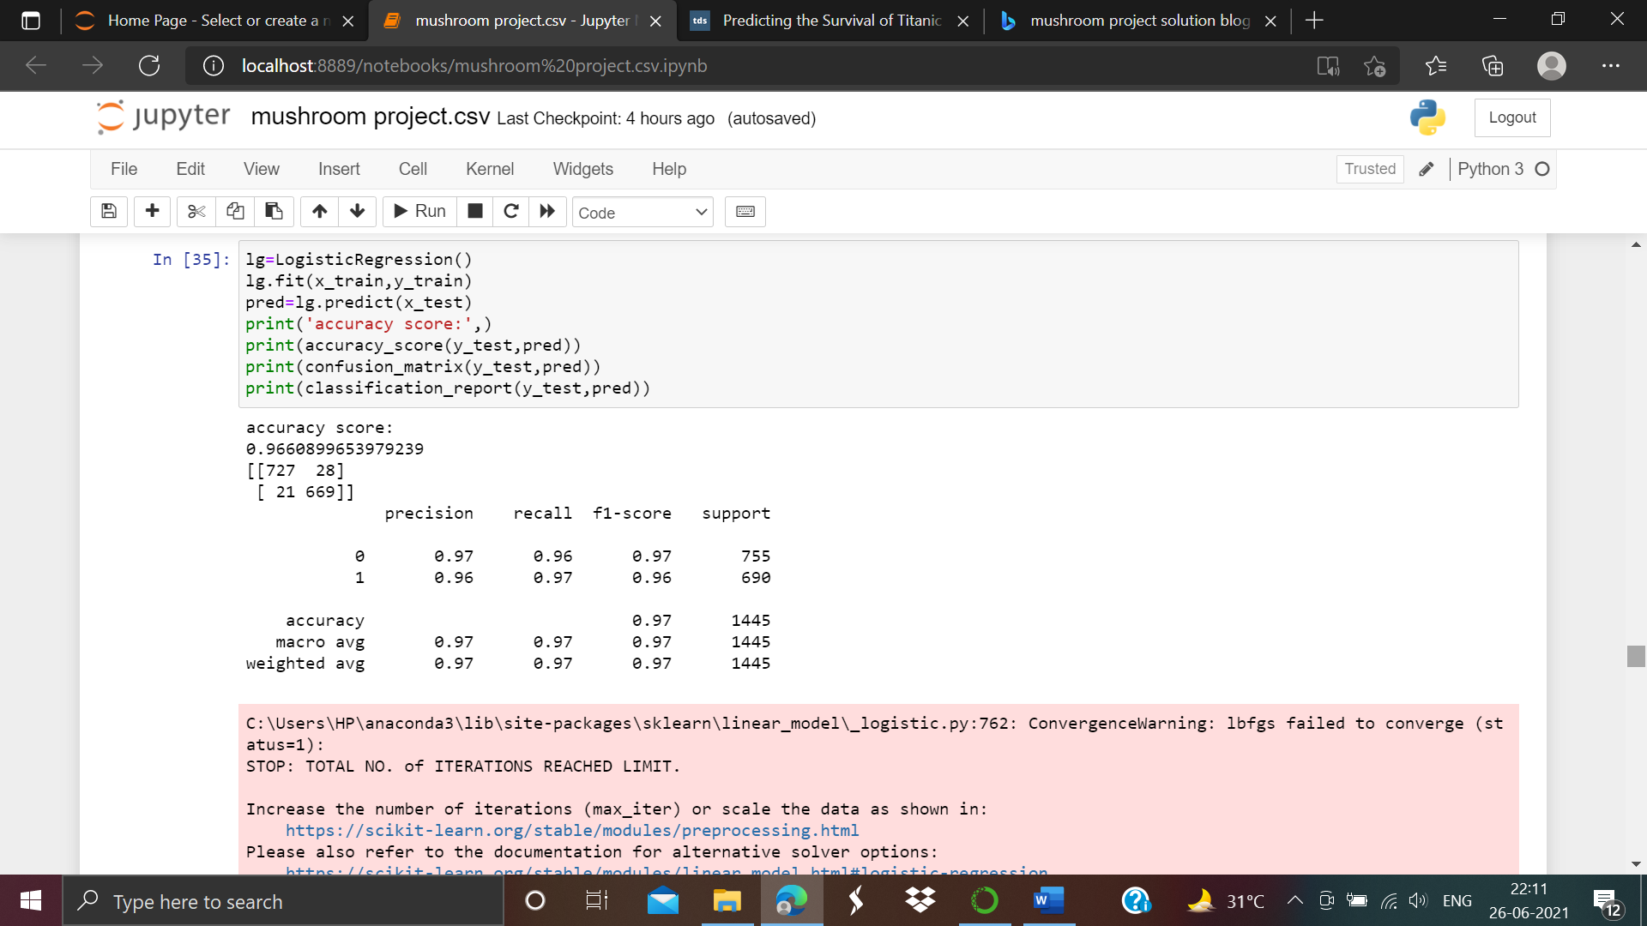

Here we can see the accuracy of the model is 97%

DecisionTreeClassifier

Our second model is decision tree classifier.In this we can see how we can apply the classification algorithms in this model. Screen shot attached below:-

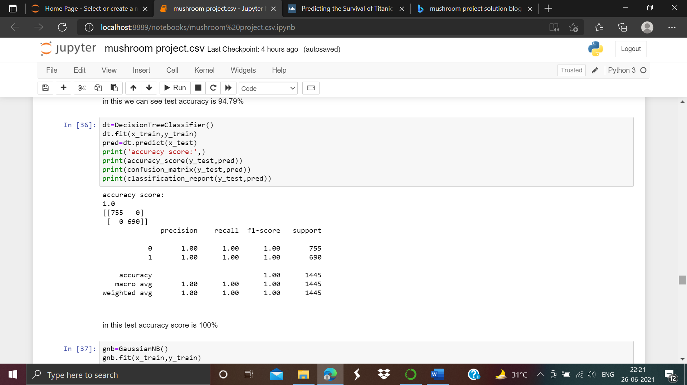

Here we can see the accuracy of this model is 100%

Naive Byes Gaussian model

Now we will use the Naive byes classification algorithms, as screen shot attached below:-

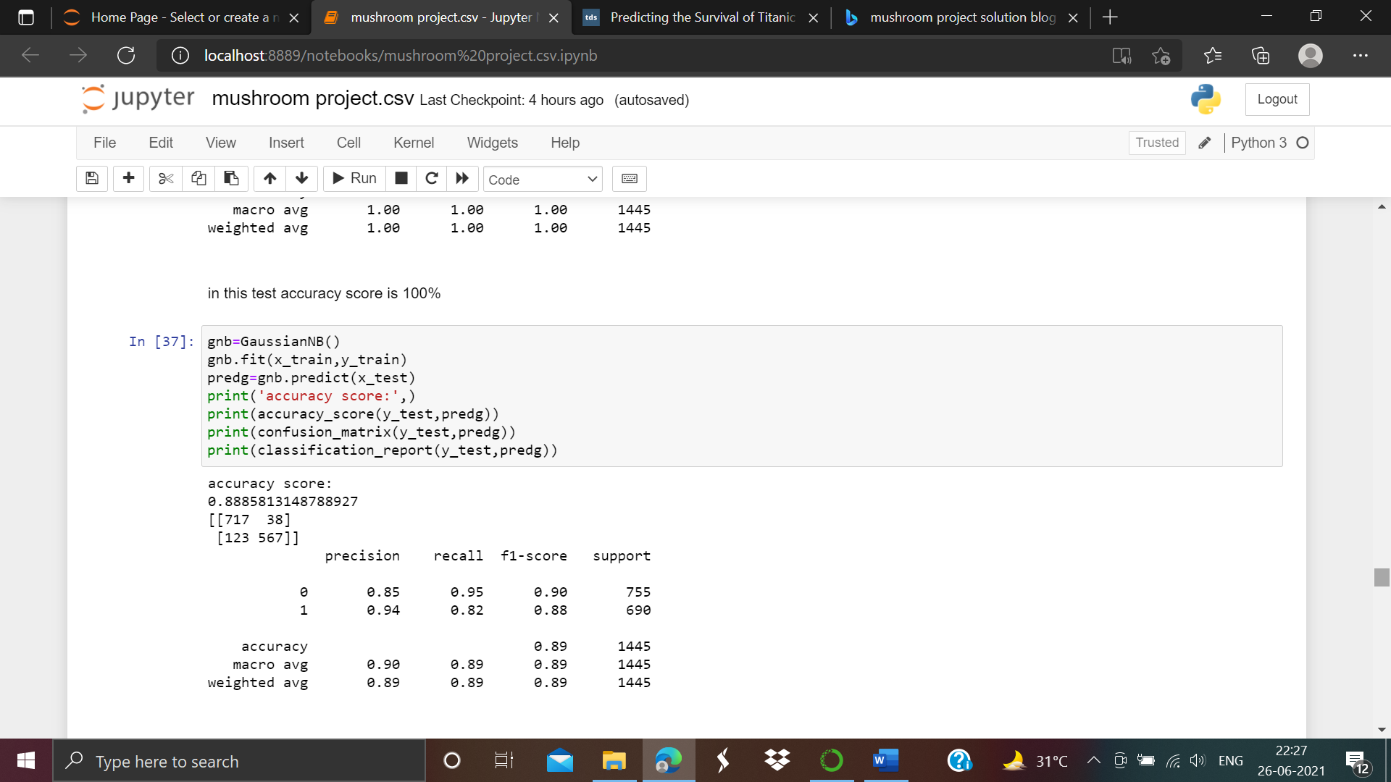

As we can see the accuracy of this model is 89%.

Support Vector Classifier (SVC)

Now we are going to use support vector classification algorithms to find the accuracy of the model which is shown below:-

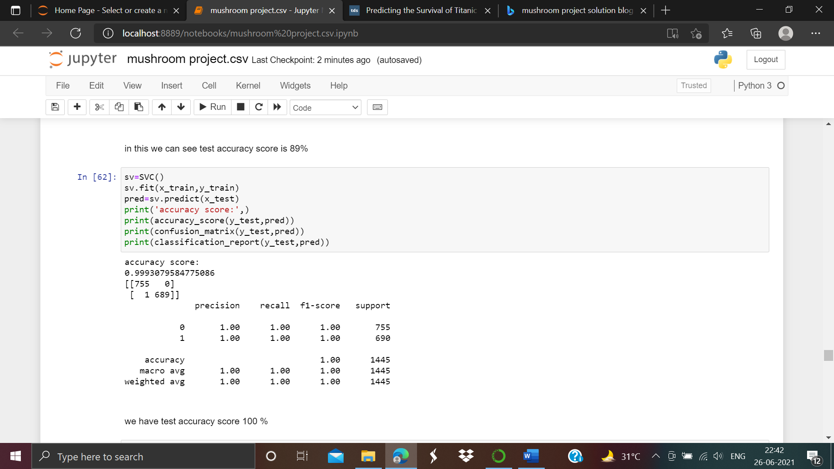

From the above we observed that the accuracy is 100%

Random Forest Classifier

As we take the random forest classification model and apply the algorithms to find out the accuracy of the model which is shown below:-

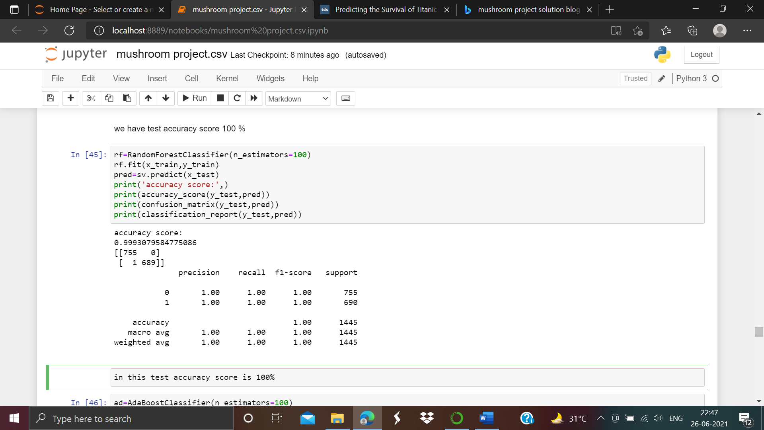

Here we can also see the accuracy comes again 100%.

Cross validation of the models

We have to find out the cross validation score for better accuracy of the model that which model is performed well or not. For this we have to cross validate the different- 2 classification models.

First of all we have to import cross validation score:-

from sklearn.model_selection import cross_val_score

import joblib

import warnings

warnings.filterwarnings('ignore')

After importing the cross_val_score we have to check cross validation scores of different-2 models as shown below:-

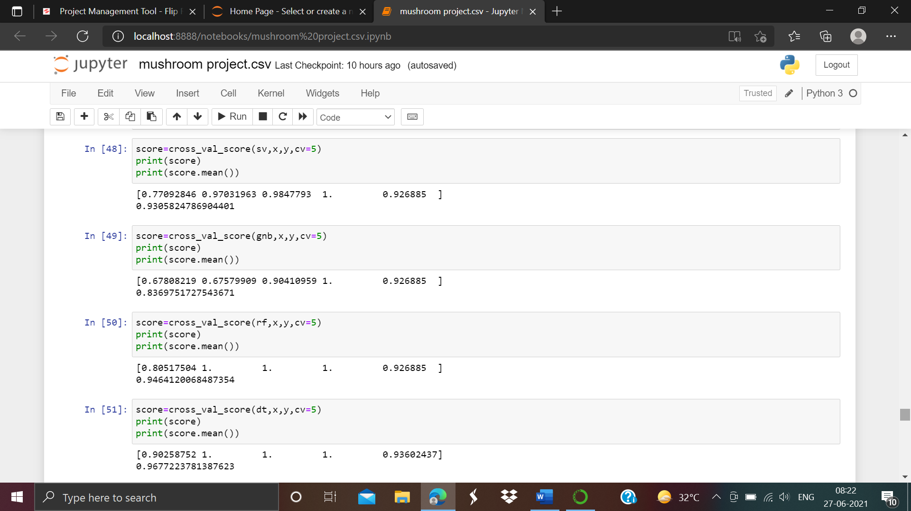

Above we can see the different-2 model’s cross validation score respectively. Support vector classifier is having score is approx. 93%

Naive byes gaussian(NB) is having the score is 83%

Random forest classifier is having cross validation score is approx. 94%

Decision Tree Classifier is having the score is approx. 97%

After getting the cross validation scores of our classification models we observed that Decision tree classifier has the highest cross validation score which is approx. 97% as compared to other models.

Now we have to move on hyper parameter tuning for better performance of our model.

**Hyper Parameter Tunning**

If we want that our model is performed well then we have to check hyper parameter tunning. For this we have to move grid search of our model. First of all we have to import the grid search cross validation as screen shot is given below:-

Let’s have a look:-

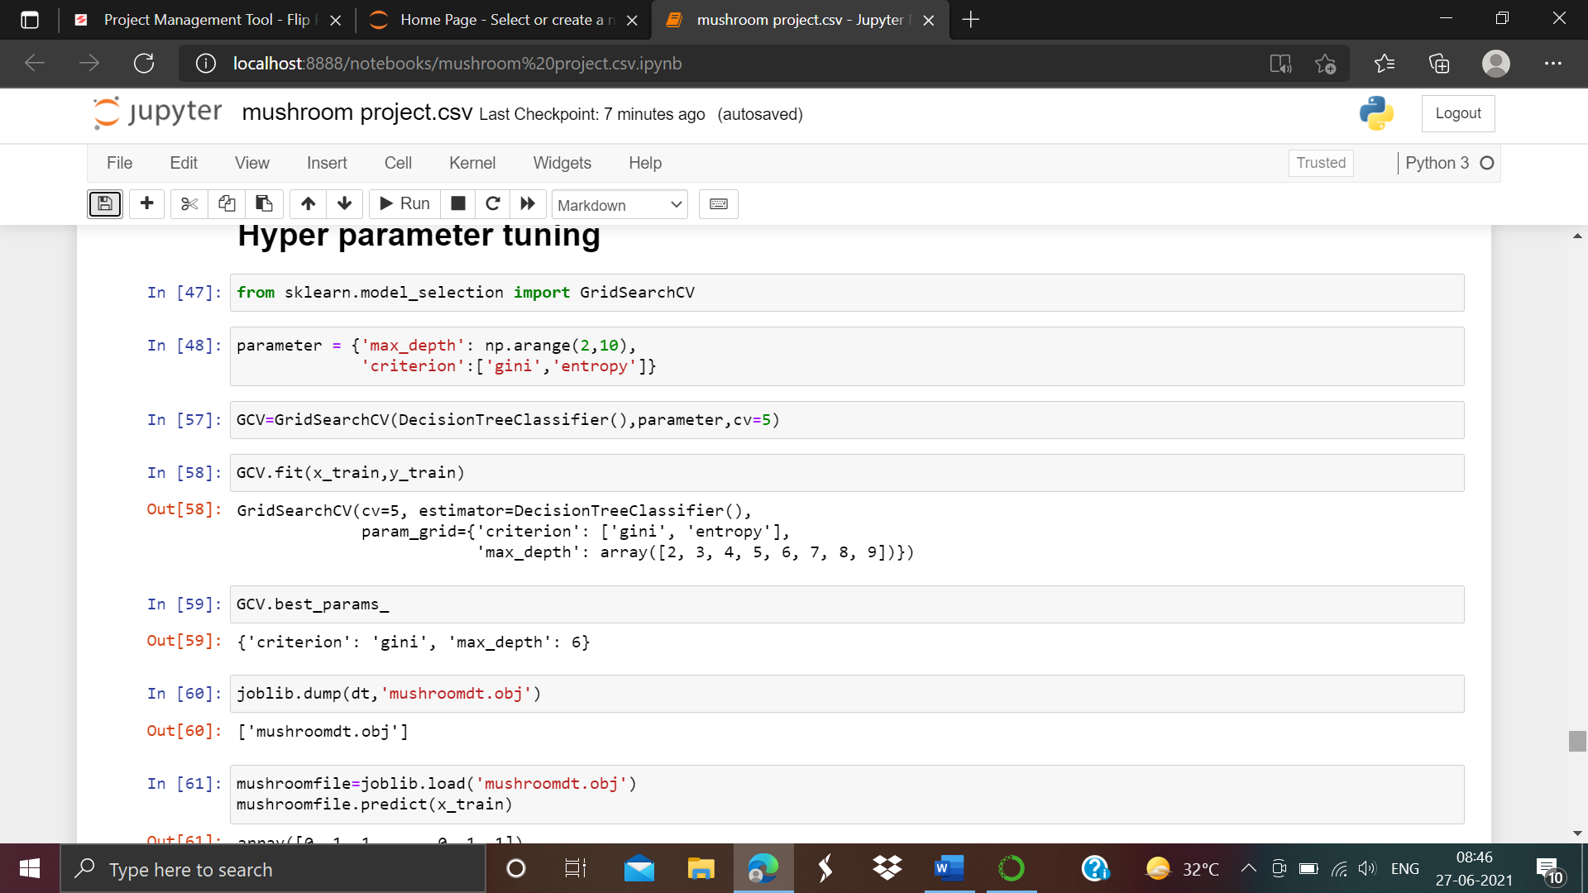

From the above we can see that we have selected our best model. We have used the parameters maximum depth ranges between from (2 to 10) and also used criterion named ‘gini’ and ‘entropy’. As we observed that Decision Tree Classifier model is our best model so we have used it to fitted best suitable model as we can see the results cv=5, estimator is Decision Tree Classifier(), parametric grid is ‘gini’ and ‘entropy’ having maximumdepth comes as output 'max_depth': array([2, 3, 4, 5, 6, 7, 8, 9]).

Now we have find best parameters of our model. As we can see in above screen shot our best criterion is ‘gini’ having maximum depth is 6.

Save and load of the model

Finding an accurate machine learning model is just not the end of the project. We also save and load the our model in proper format. This will gives us the brief idea to save our model to file and load it later to make better predictions.

In this project we have used joblib operation which is useful for some machine learning algorithms that requires a lot of parameters or we can say store the entire dataset.As screen shot attached below:-

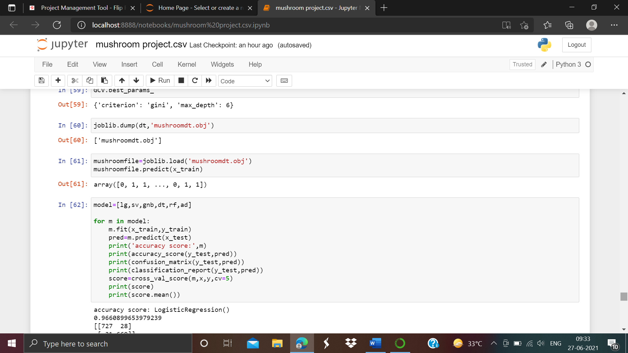

As we can see above we have saved our model to file as ‘mushroomdt.obj’ format

And also creates one file for each numpy array in the model.This also serializing the our project objects with numpy arrays.

After the model is loaded we have to estimate the accuracy of our best model.

The accuracy of our best model is 100% with cross validation score is approx. 97%.

Conclusion

As we observed that in this project with confusion matrix our train and test data's are balanced,so there is no problem.

most of the classification methods reaches at 100% accuracy with the dataset.

Oh Great!!Now we can eat Healthy mushrooms!!Yummy mushrooms!!